**FINAL SIMULATION FOR HEART SOUNDS**

**=====================================================**

**SYM 2**

| **SYM 2** | **No of Delay** | **SNRdB_Heart_Sound** | **RMSE_Heart _Sound** | **PRD_Heart_Sound** | **CC_Heart**  **_Sound** |
| --- | --- | --- | --- | --- | --- |
| Level 2 | 39 | 24.4493 dB | 9.7728e-05 | 5.9915% | 0.96656 |
| Level 3 | 72 | 24.7633 dB | 9.5602e-05 | 5.7788% | 0.96794 |
| Level 4 | 105 | 24.9014 dB | 9.4105e-05 | 5.6876% | 0.96894 |
| Level 5 | 140 | 25.4428 dB | 8.7117e-05 | 5.3439% | 0.9734 |
| Level 6 | 175 | 25.9929 dB | 8.18e-05 | 5.016% | 0.97648 |
| Level 7 | 210 | 26.2876 dB | 7.9066e-05 | 4.8486% | 0.97815 |

**++++++++++++++++++++++++++++++++++++++++++++++++++++++++++++++++++**

**(1) SYM 2 LEVEL 2**

(a) SYM 2 LEVEL 2 ARCHITECTURE

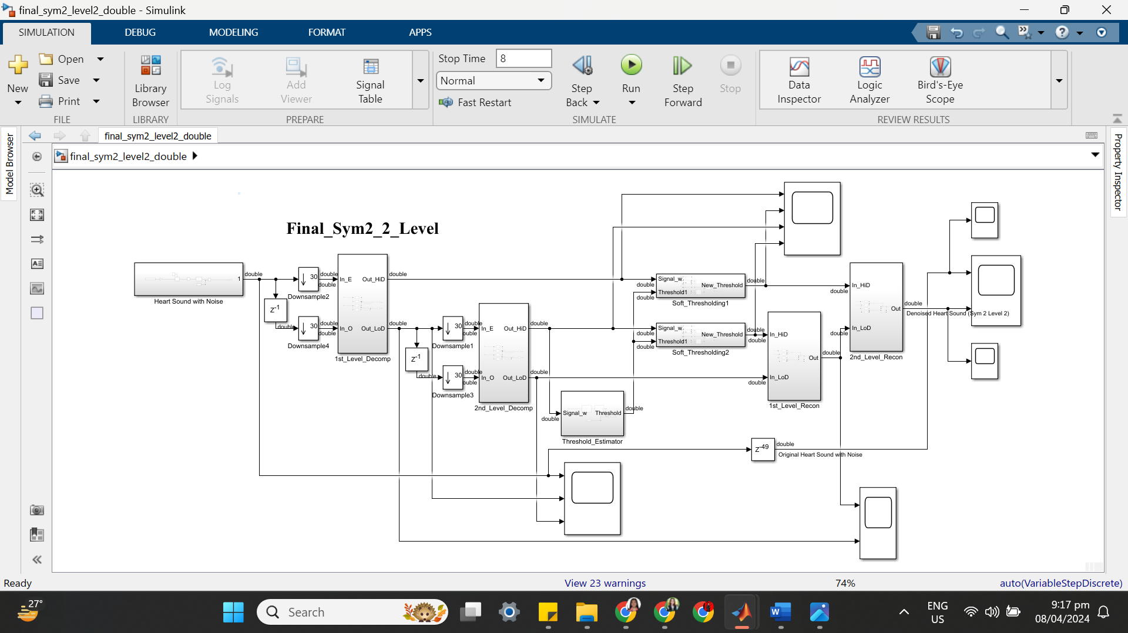

(b) SYM 2 LEVEL 2 SIMULATION RESULT

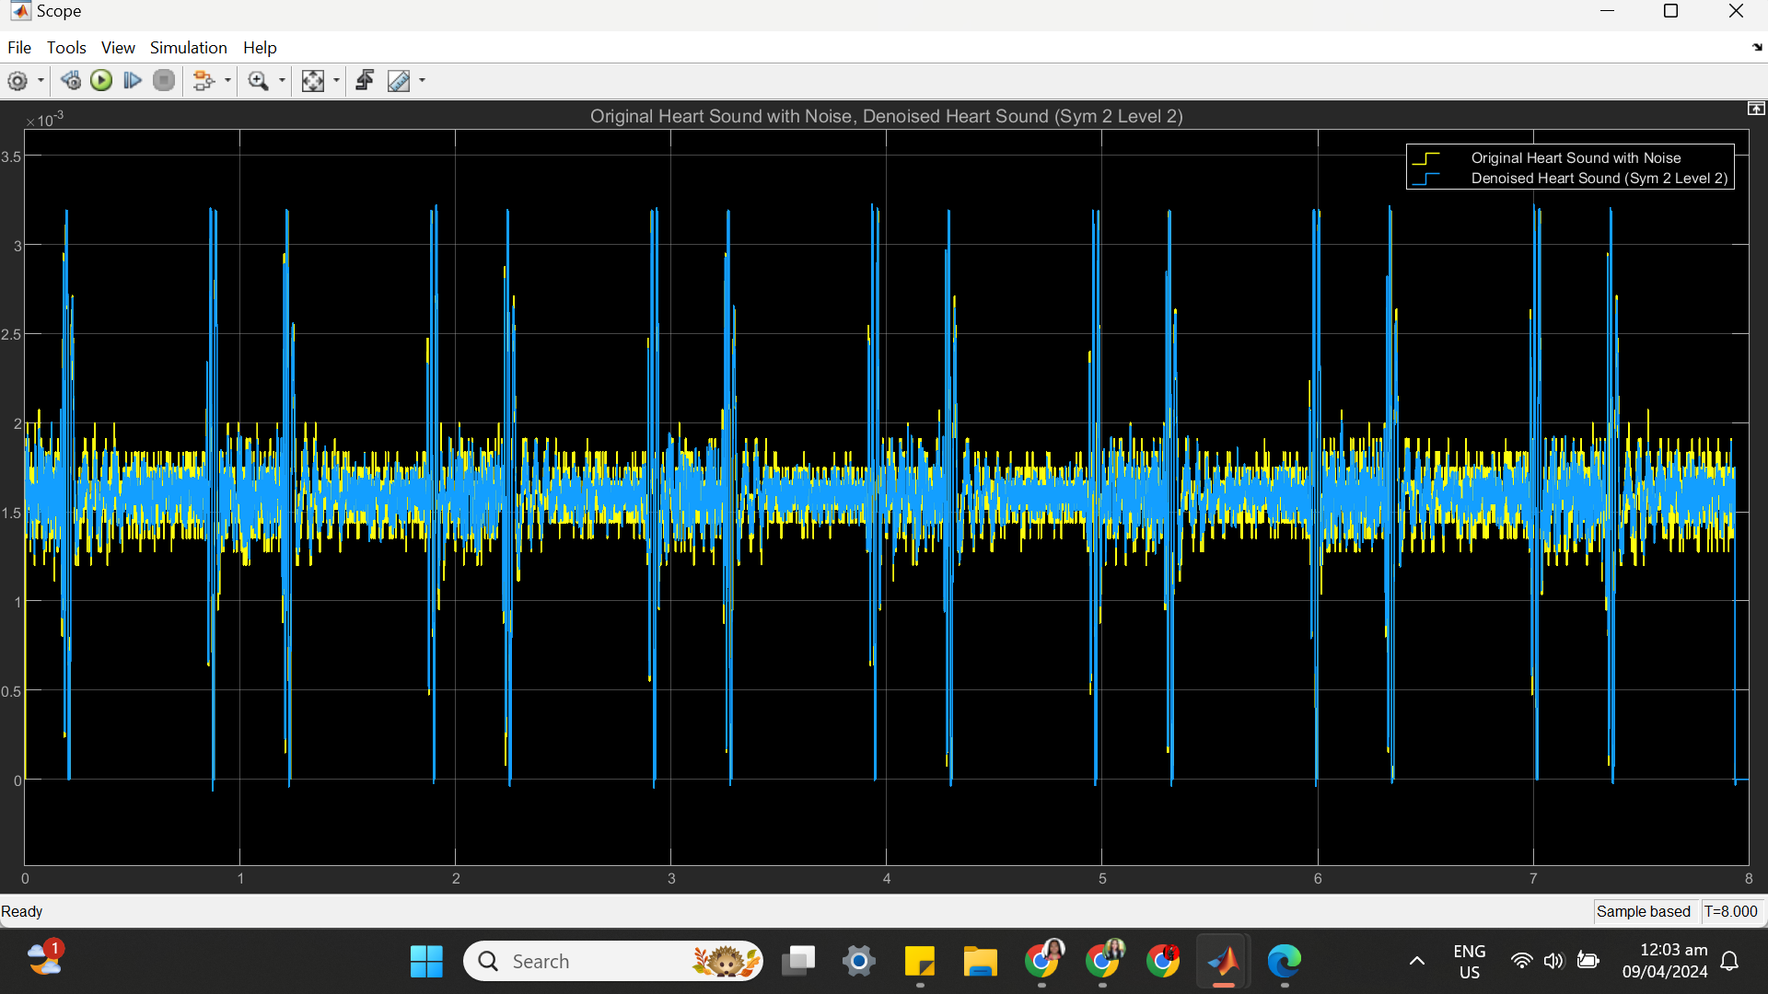

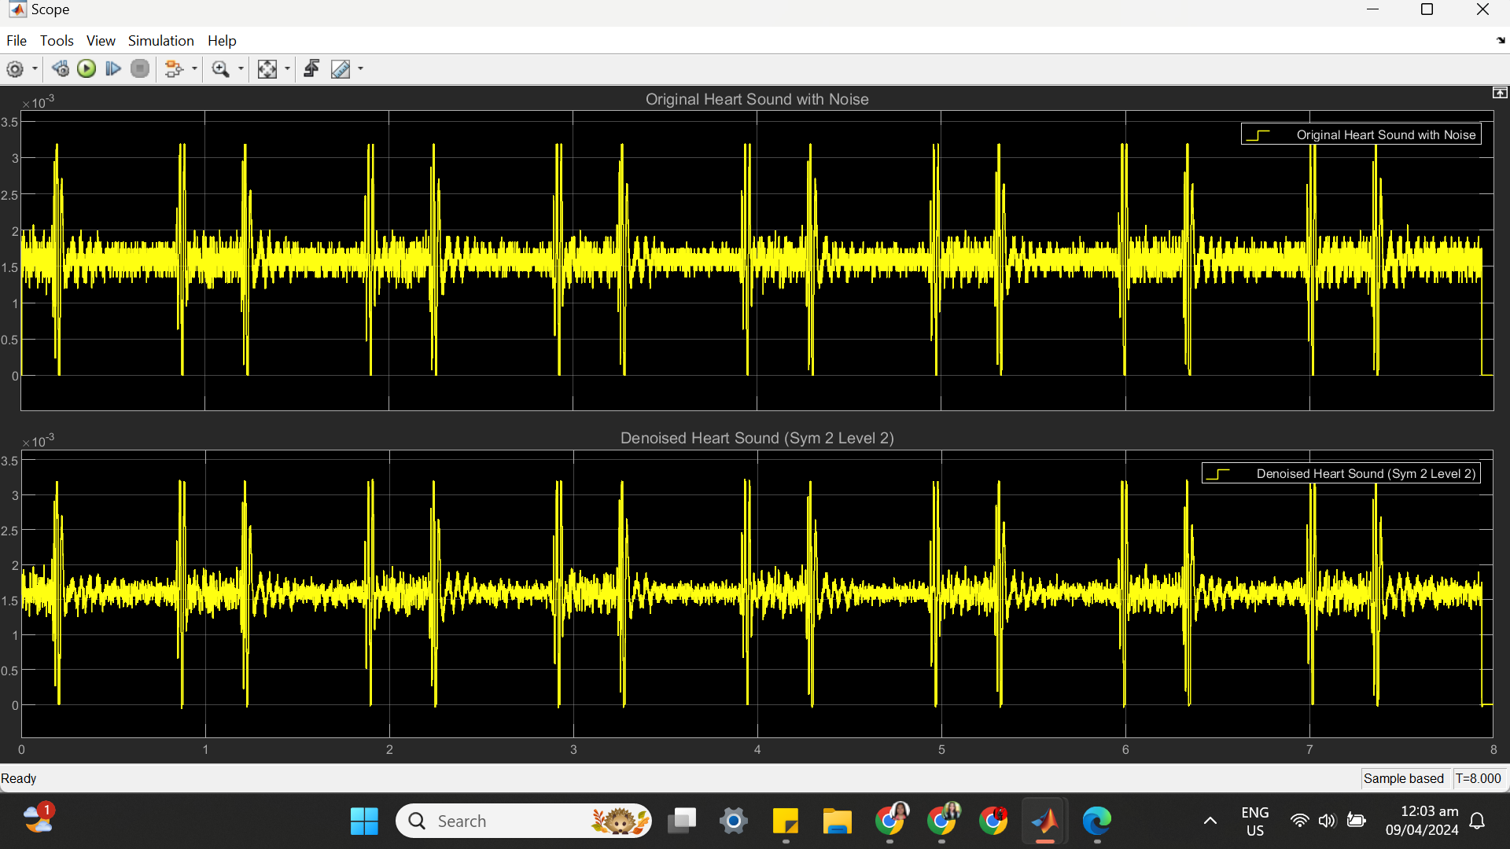

(c) SYM 2 LEVEL 2 STATISTICS RESULT

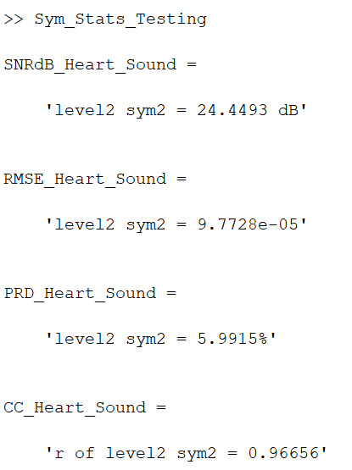

(d) SYM 2 LEVEL 2 SCATTER PLOT RESULT

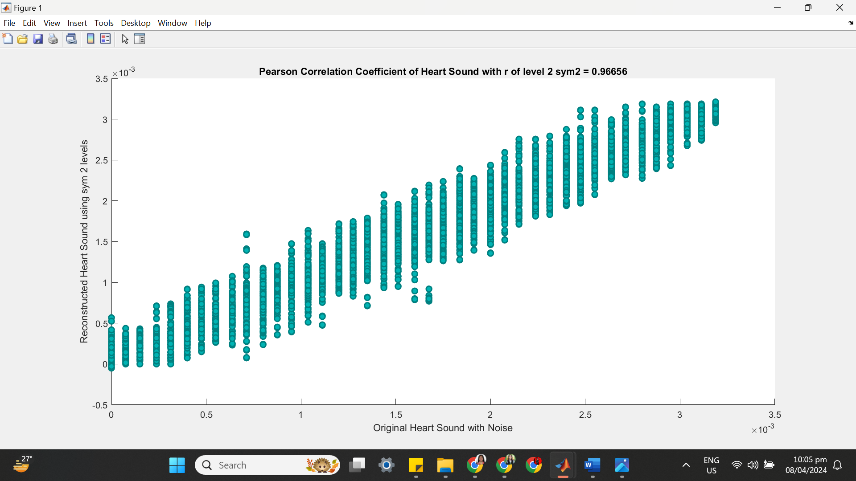

**++++++++++++++++++++++++++++++++++++++++++++++++++++++++++++++++++**

**(2) SYM 2 LEVEL 3**

(a) SYM 2 LEVEL 3 ARCHITECTURE

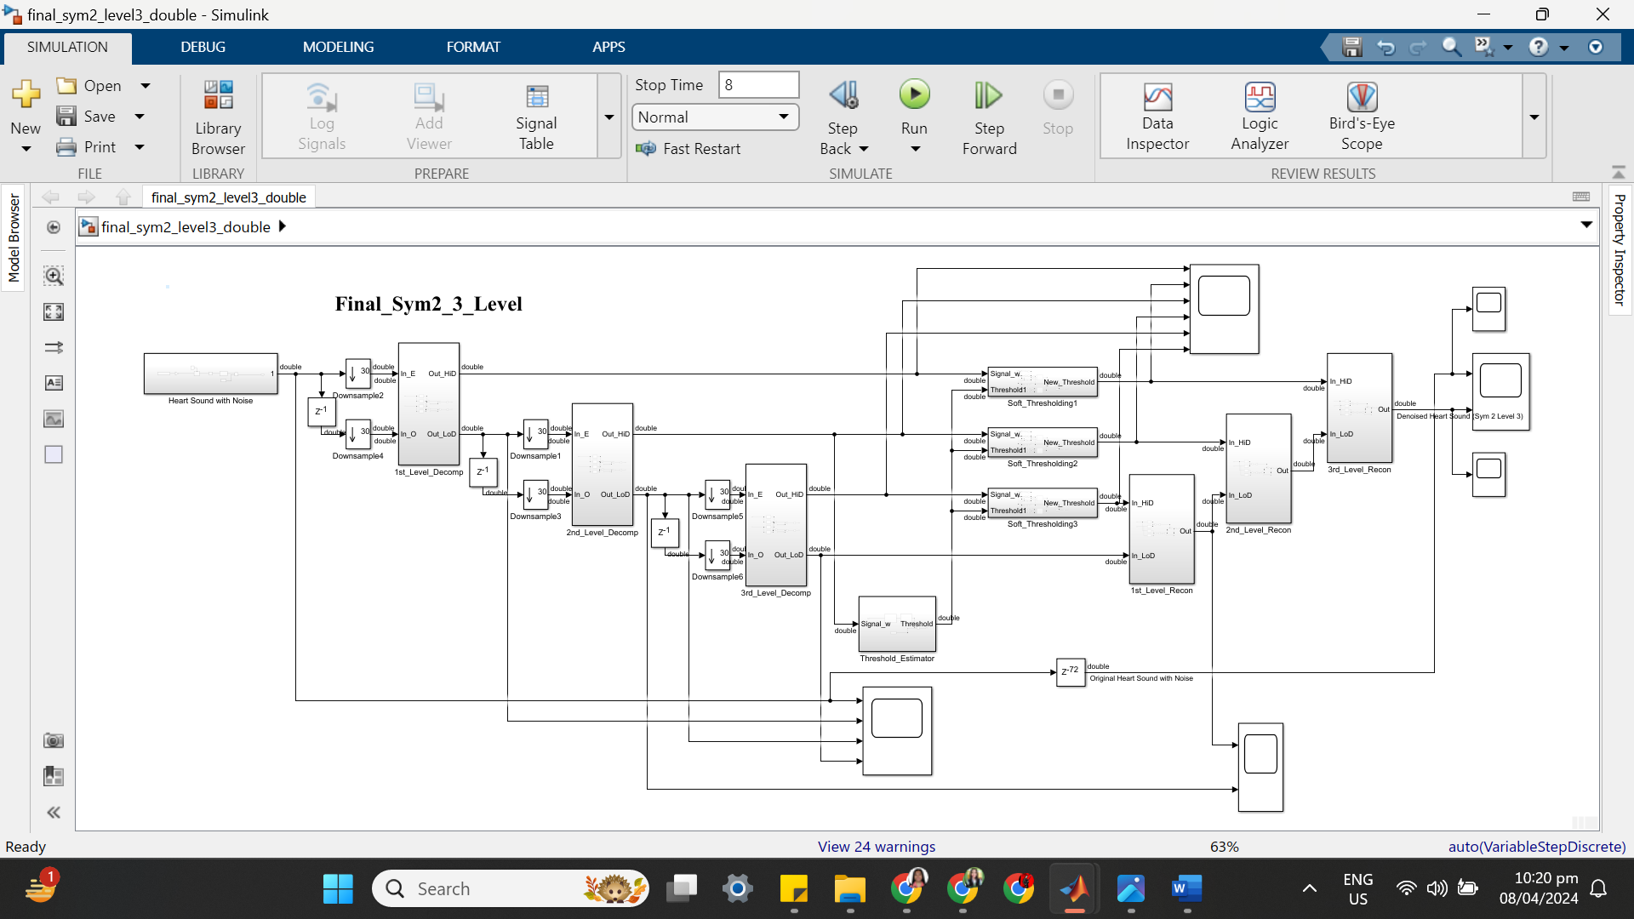

(b) SYM 2 LEVEL 3 SIMULATION RESULT

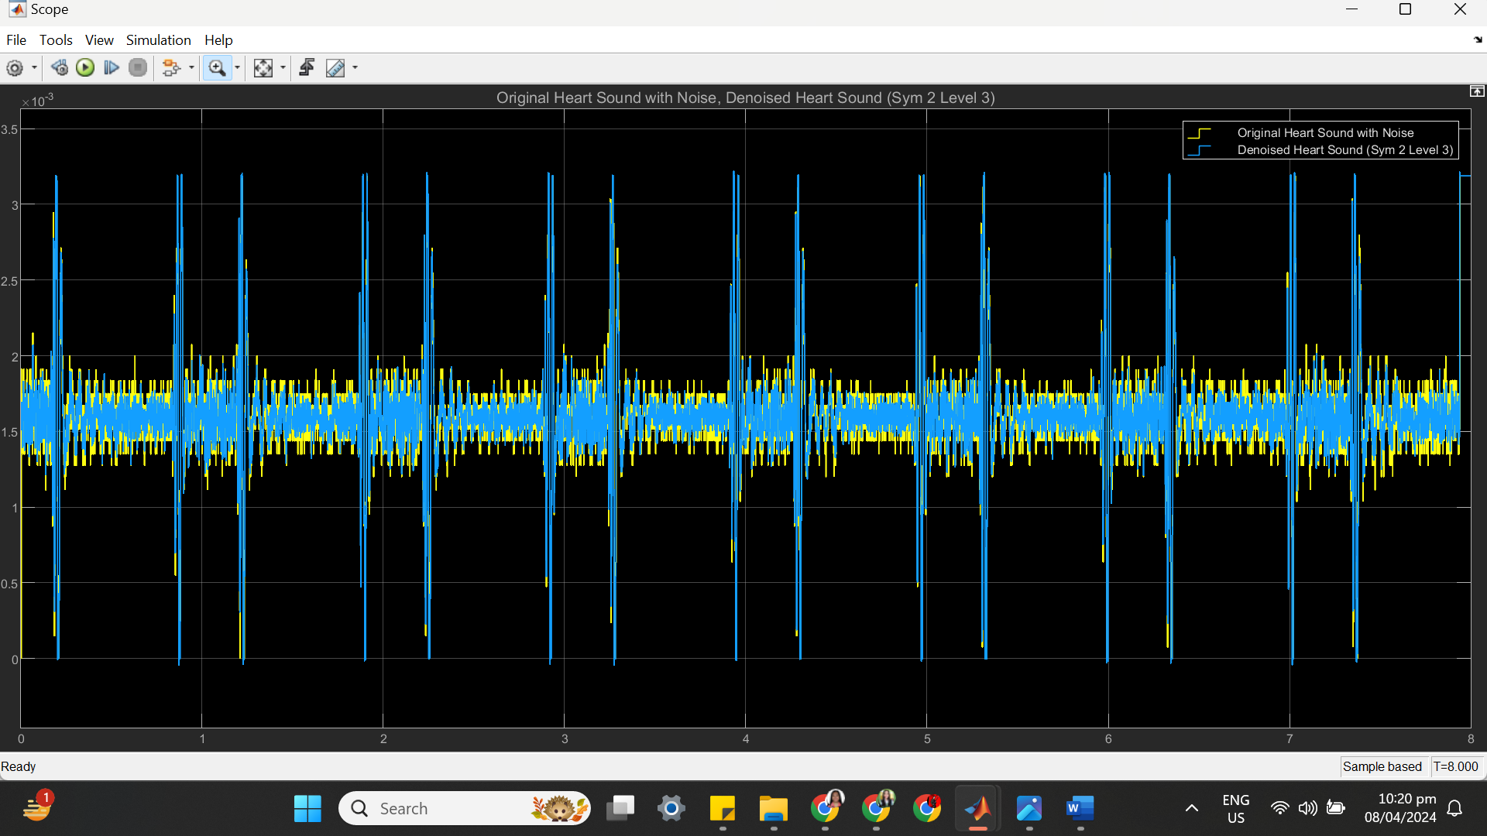

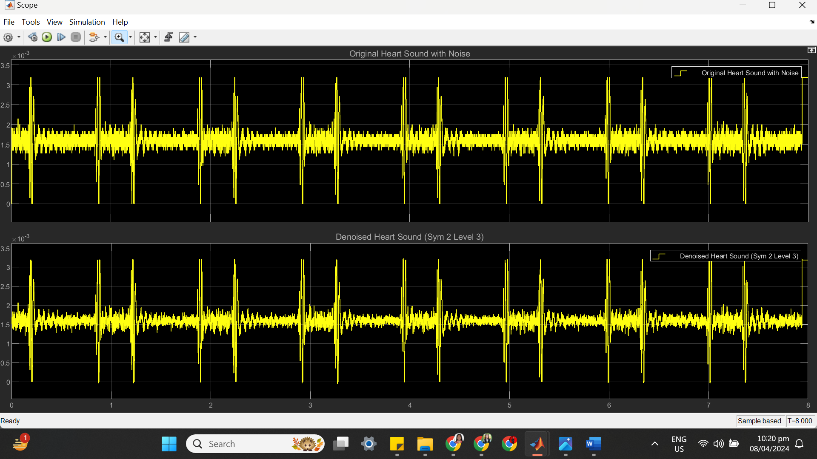

(c) SYM 2 LEVEL 3 STATISTICS RESULT

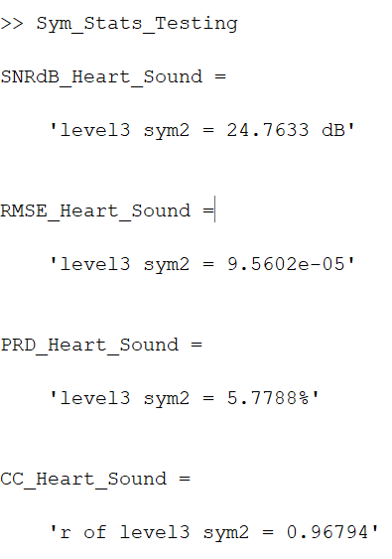

(d) SYM 2 LEVEL 3 SCATTER PLOT RESULT

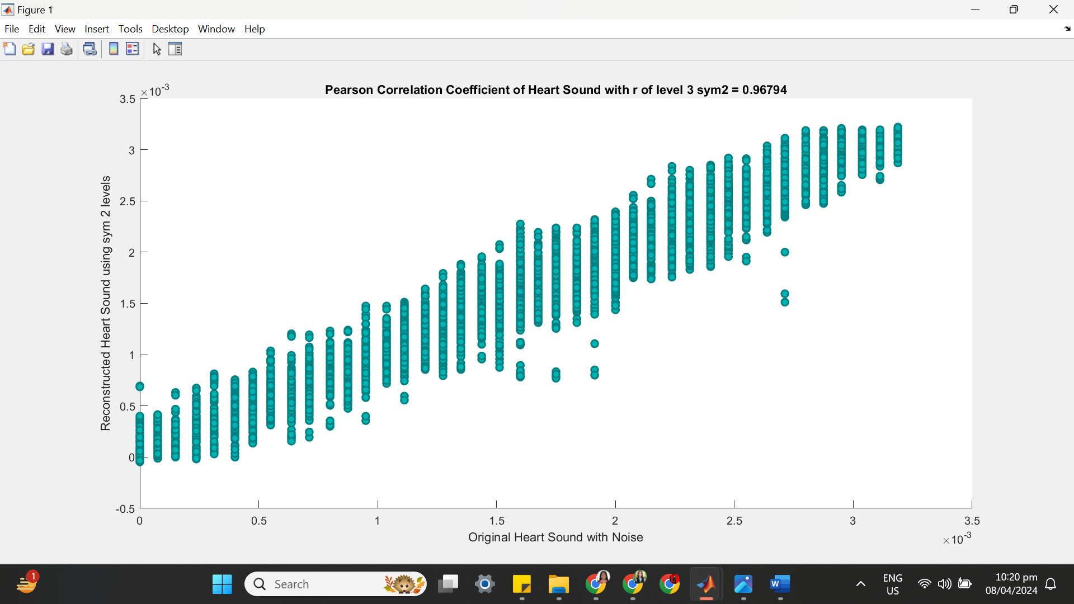

**++++++++++++++++++++++++++++++++++++++++++++++++++++++++++++++++++**

**(3) SYM 2 LEVEL 4**

(a) SYM 2 LEVEL 4 ARCHITECTURE

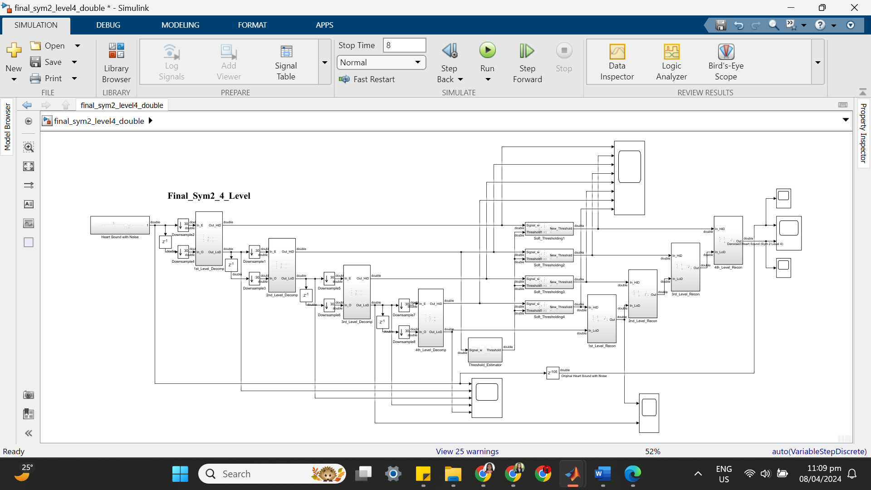

(b) SYM 2 LEVEL 4 SIMULATION RESULT

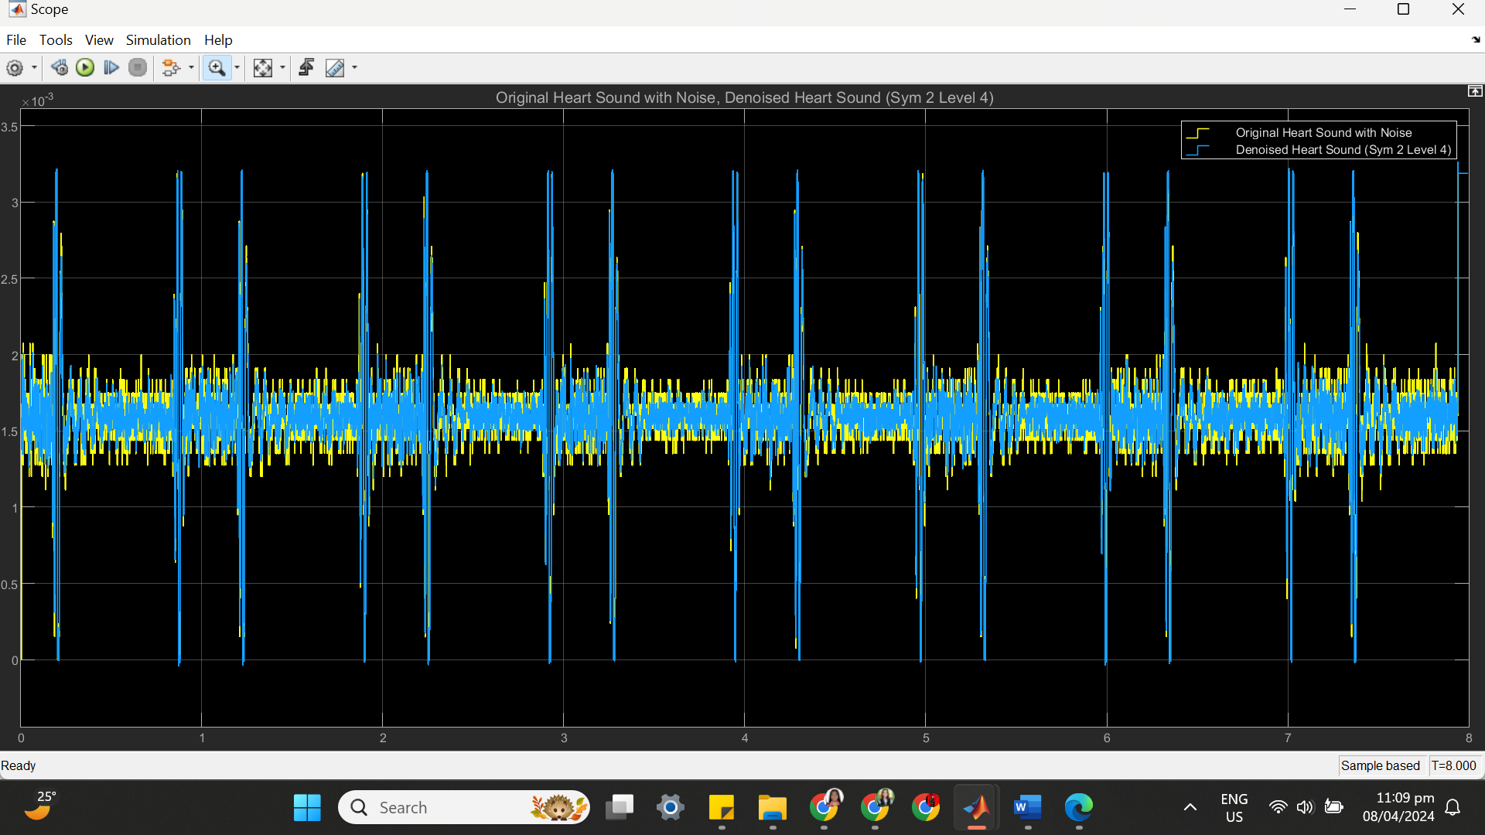

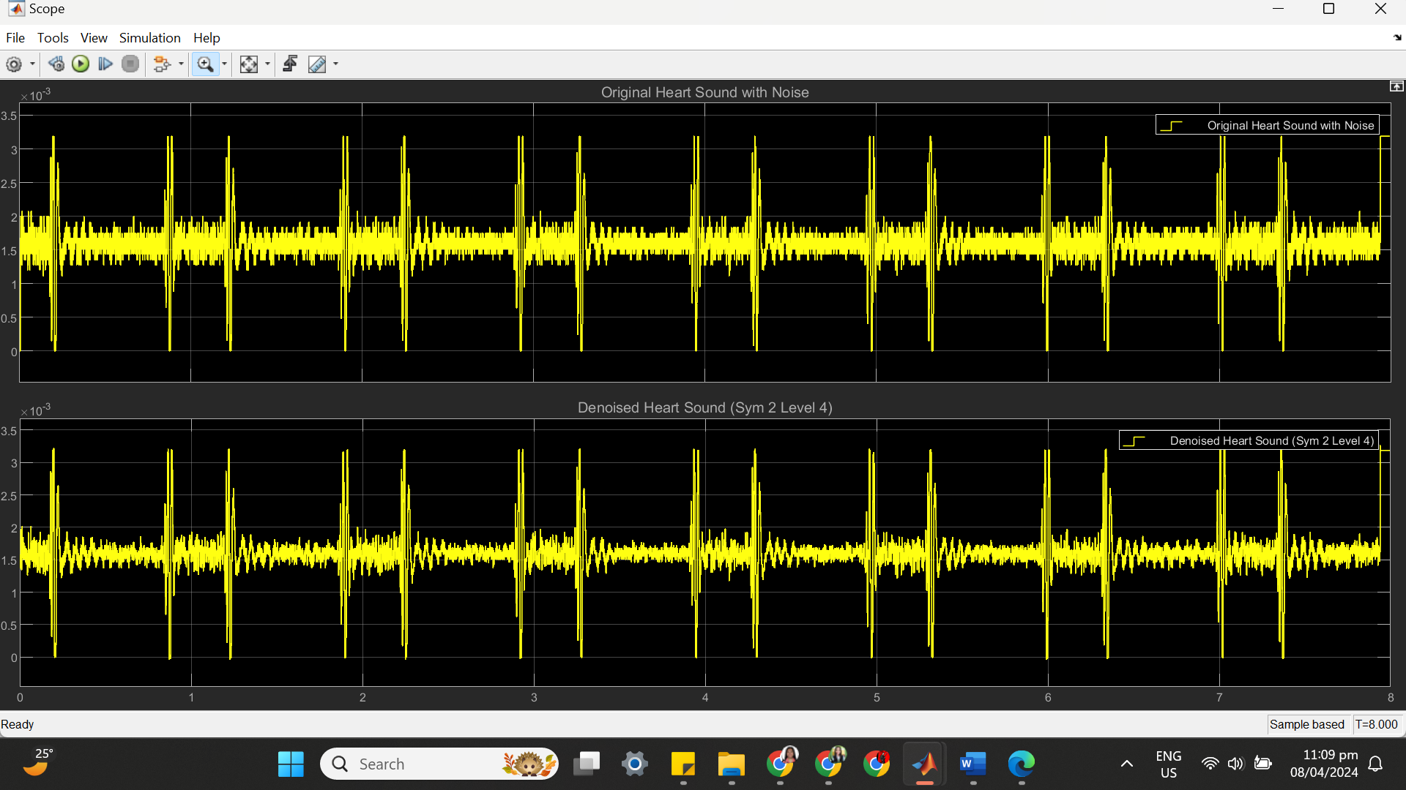

(c) SYM 2 LEVEL 4 STATISTICS RESULT

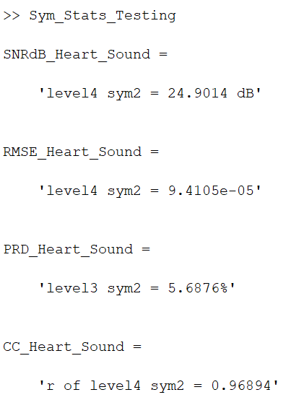

(d) SYM 2 LEVEL 4 SCATTER PLOT RESULT

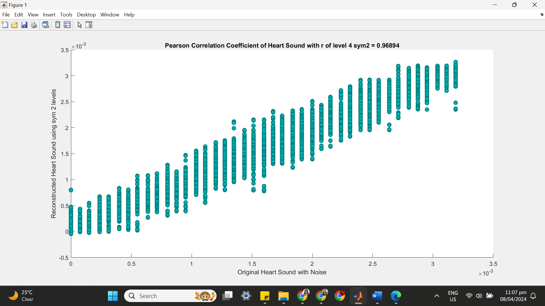

**++++++++++++++++++++++++++++++++++++++++++++++++++++++++++++++++++**

**(4) SYM 2 LEVEL 5**

(a) SYM 2 LEVEL 5 ARCHITECTURE

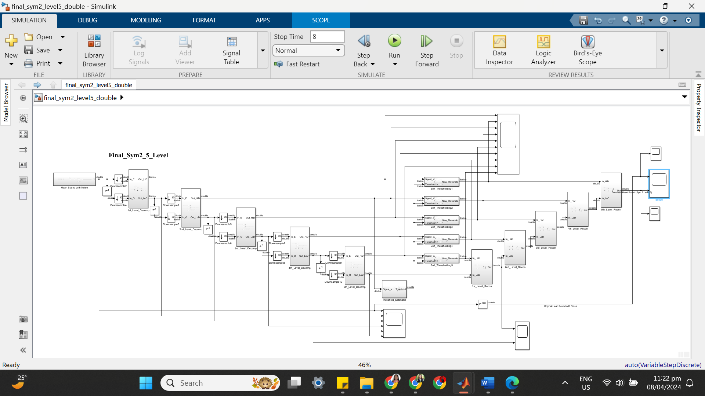

(b) SYM 2 LEVEL 5 SIMULATION RESULT

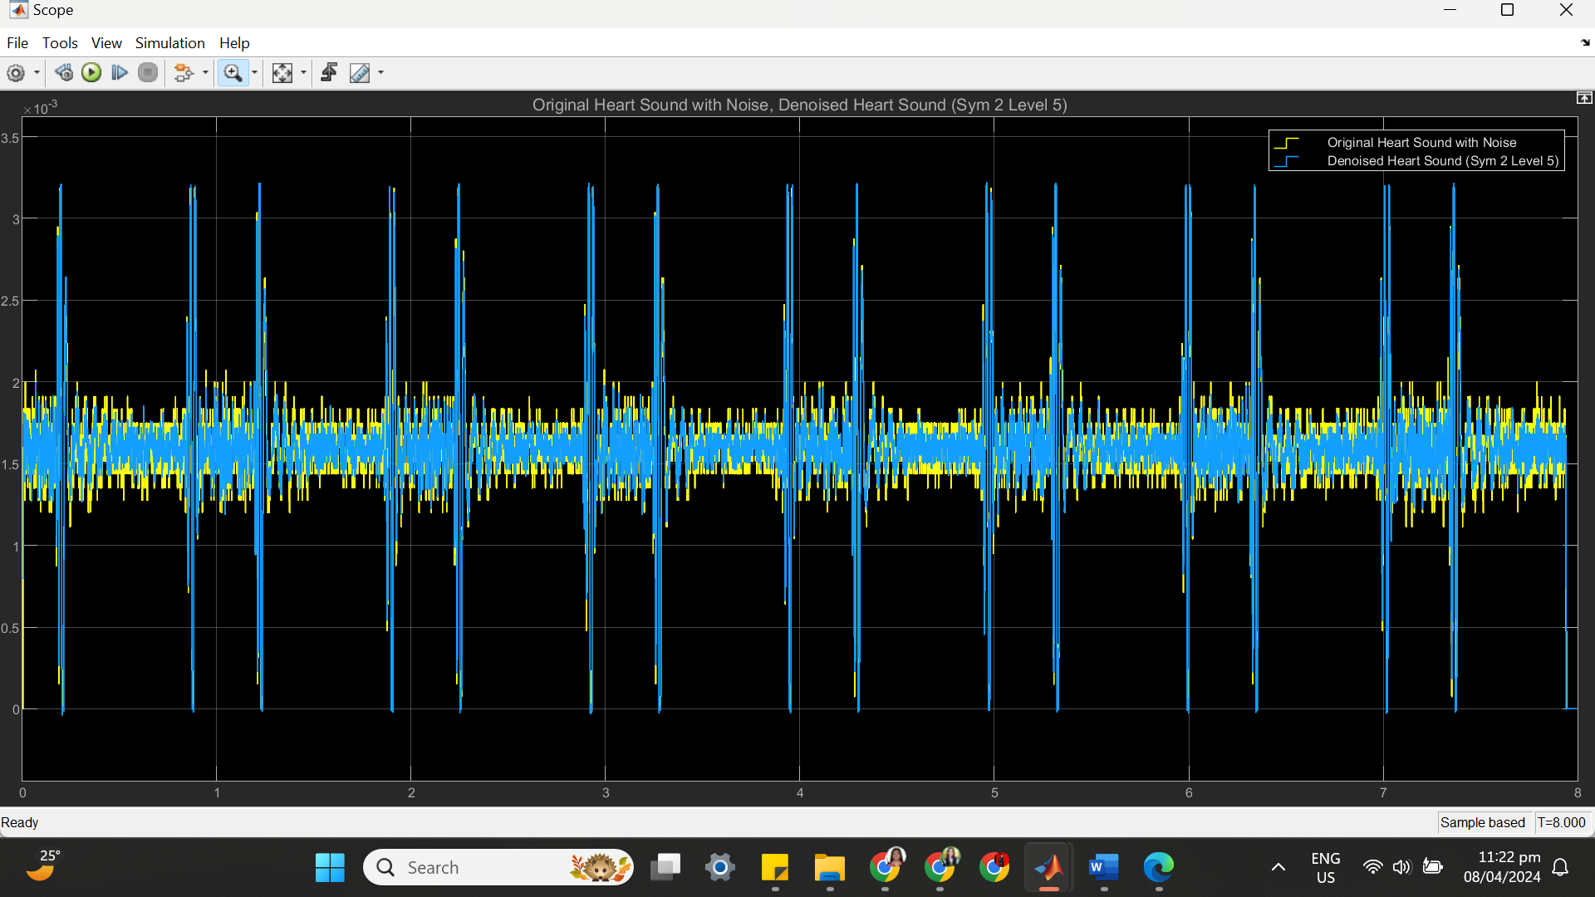

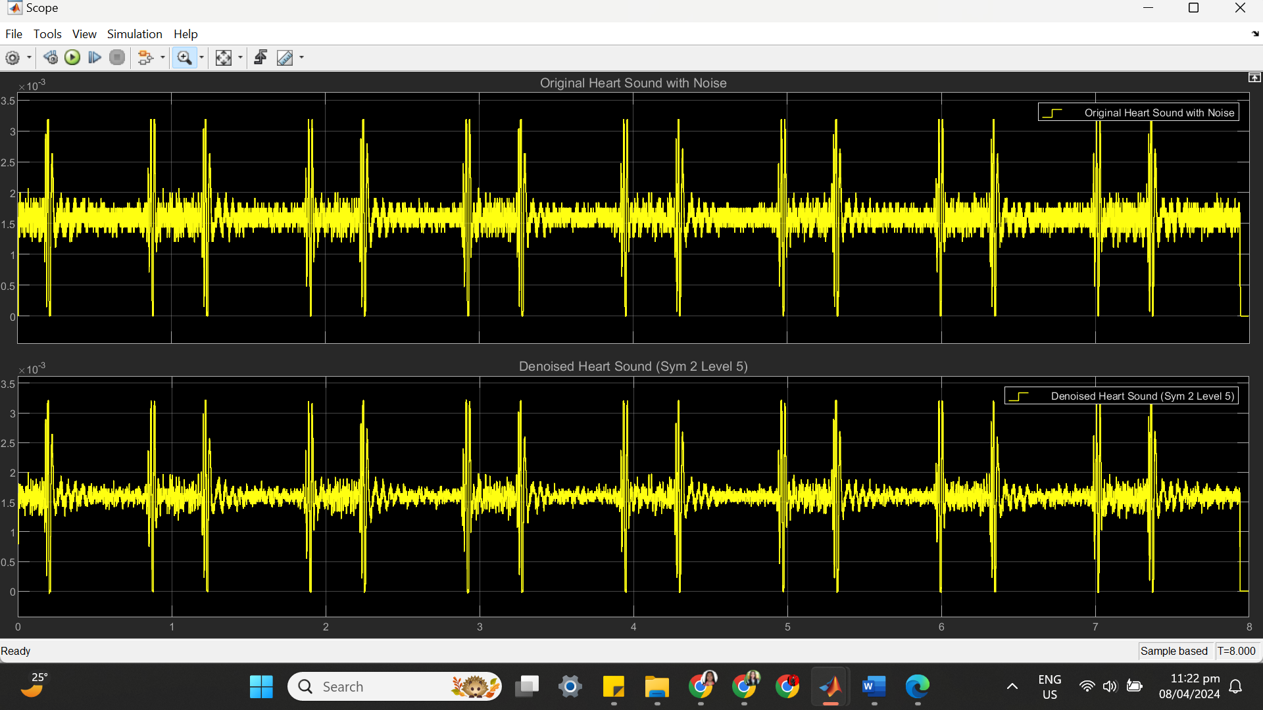

(c) SYM 2 LEVEL 5 STATISTICS RESULT

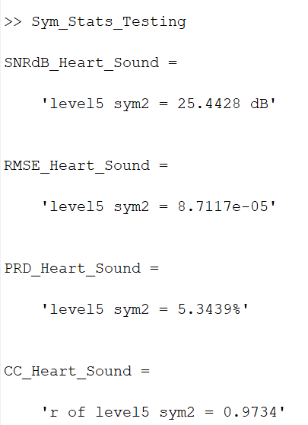

(d) SYM 2 LEVEL 5 SCATTER PLOT RESULT

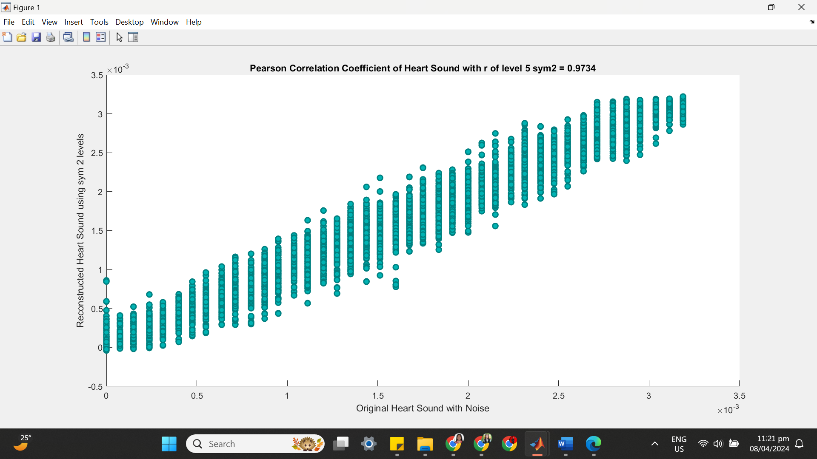

**++++++++++++++++++++++++++++++++++++++++++++++++++++++++++++++++++**

**(5) SYM 2 LEVEL 6**

(a) SYM 2 LEVEL 6 ARCHITECTURE

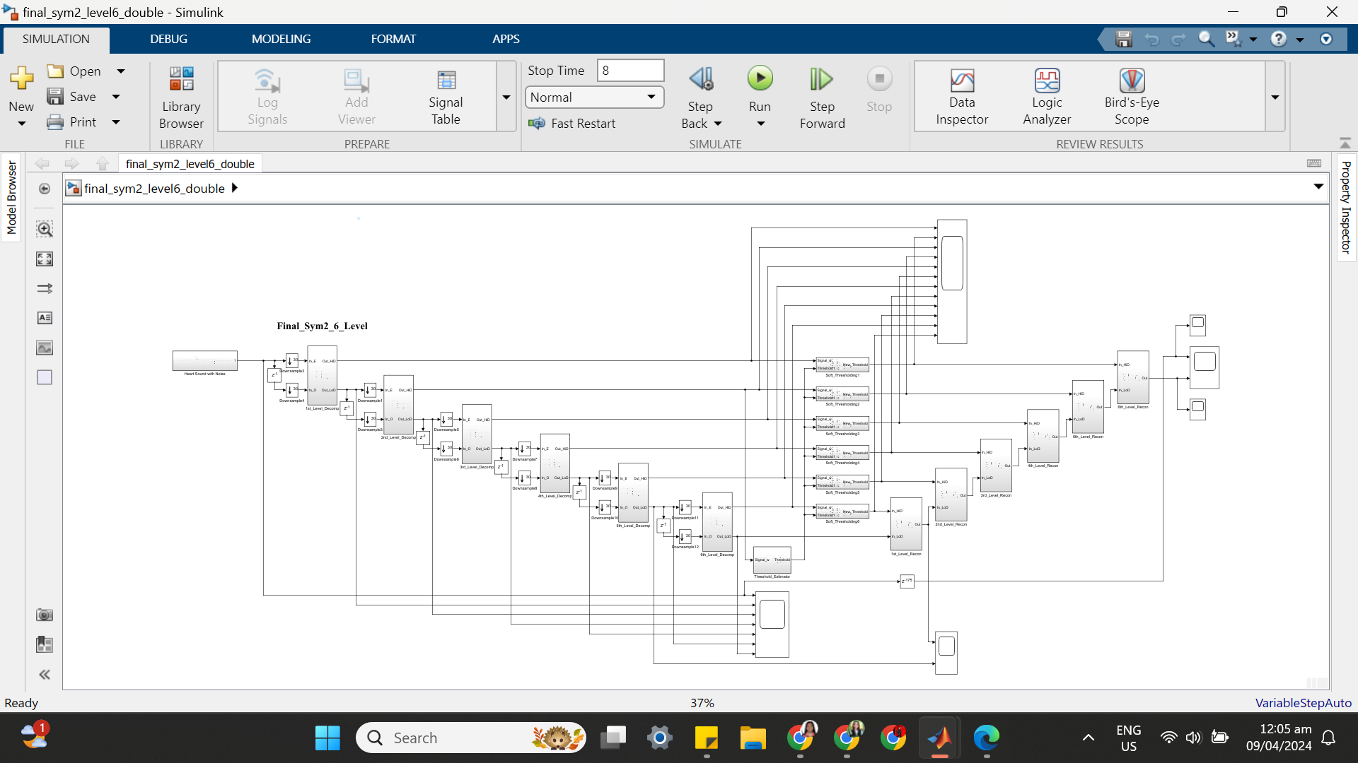

(b) SYM 2 LEVEL 6 SIMULATION RESULT

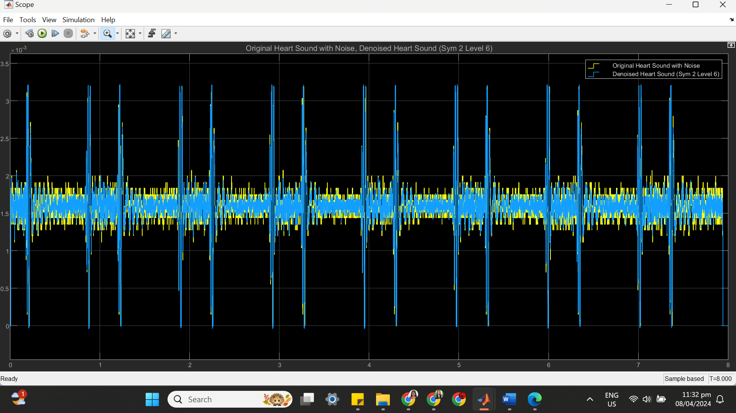

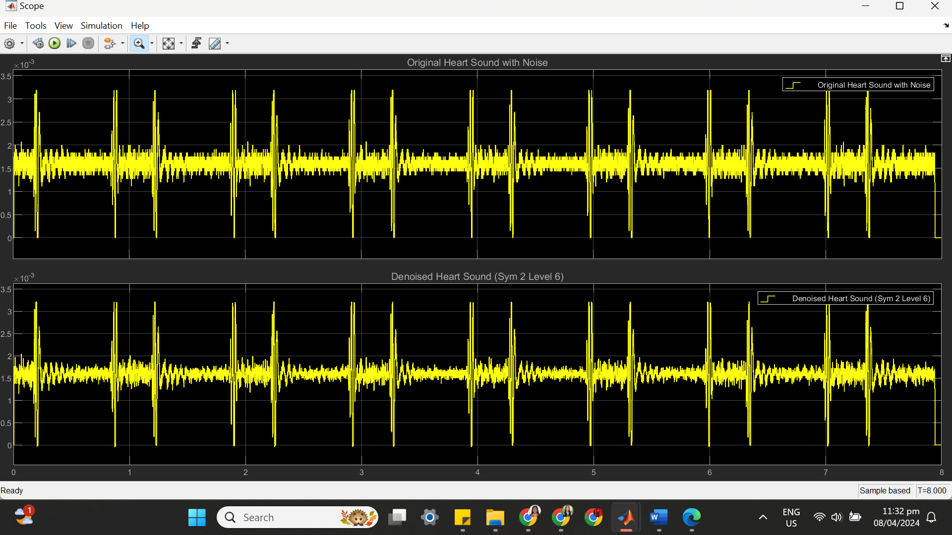

(c) SYM 2 LEVEL 6 STATISTICS RESULT

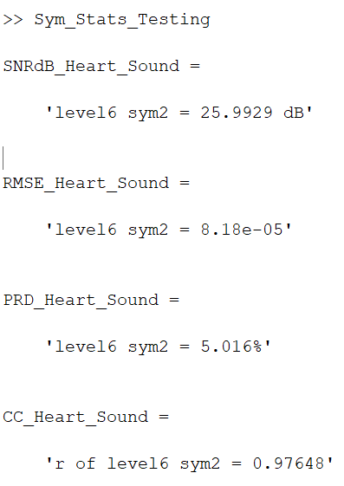

(d) SYM 2 LEVEL 6 SCATTER PLOT RESULT

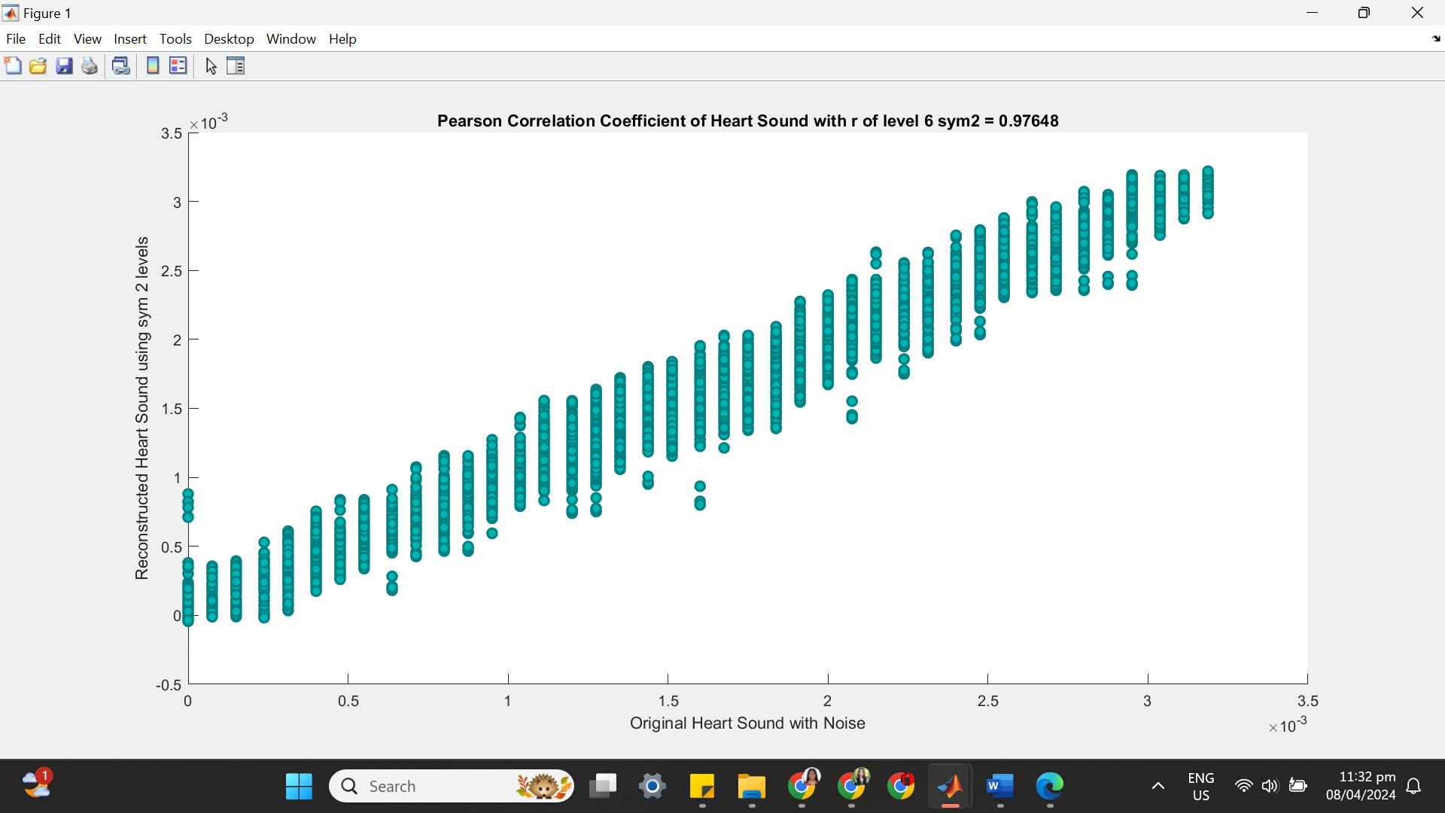

**++++++++++++++++++++++++++++++++++++++++++++++++++++++++++++++++++**

**(6) SYM 2 LEVEL 7**

(a) SYM 2 LEVEL 7 ARCHITECTURE

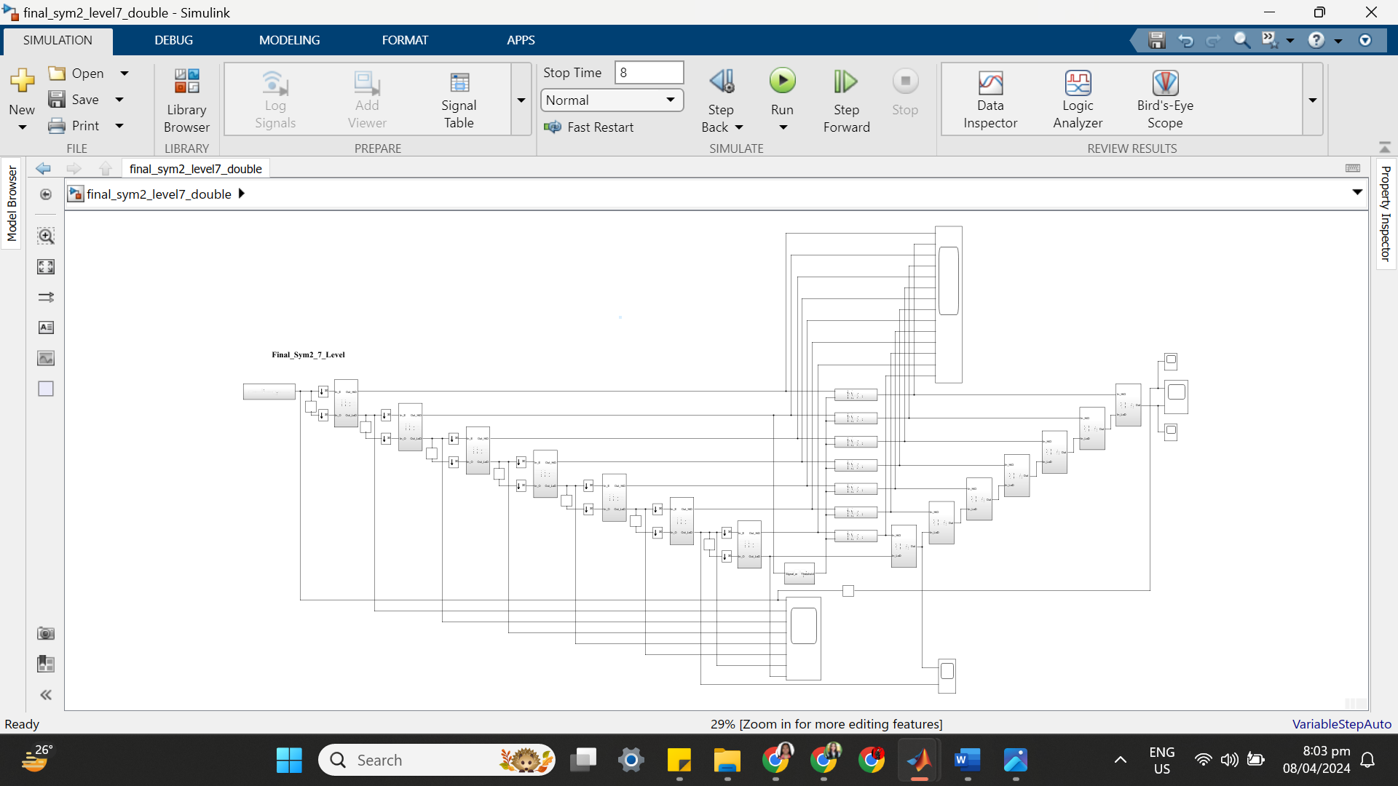

(b) SYM 2 LEVEL 7 SIMULATION RESULT

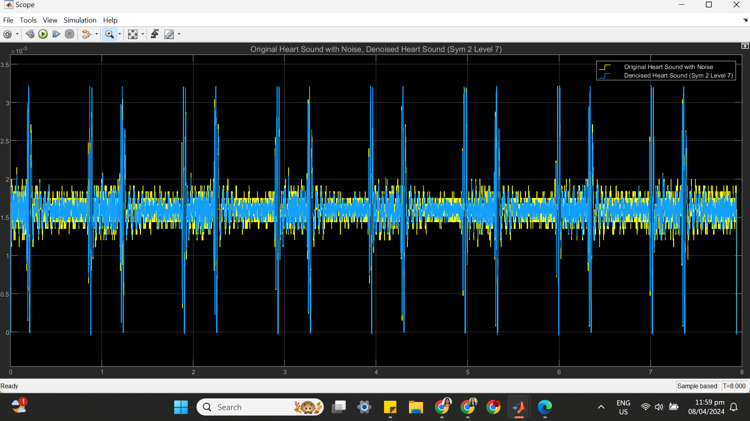

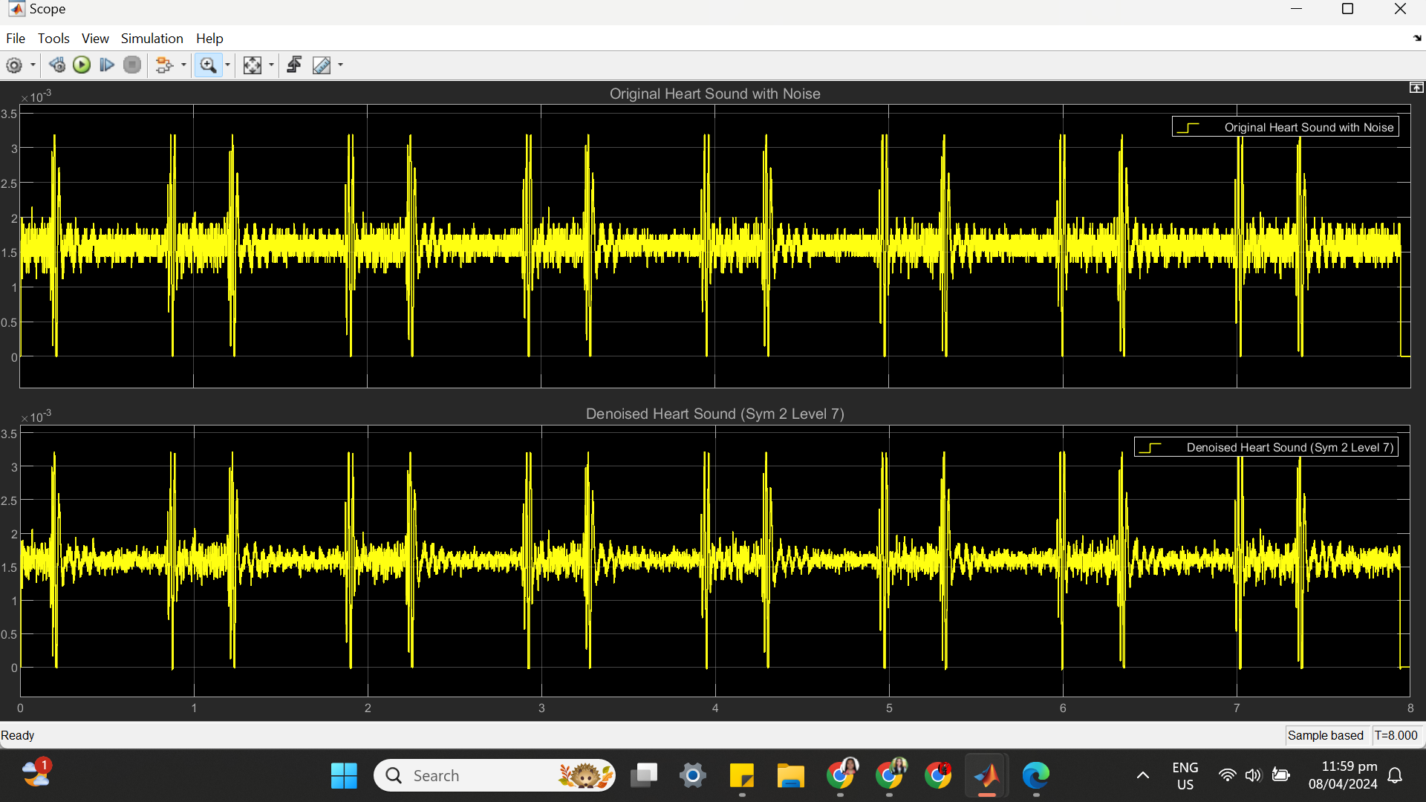

(c) SYM 2 LEVEL 7 STATISTICS RESULT

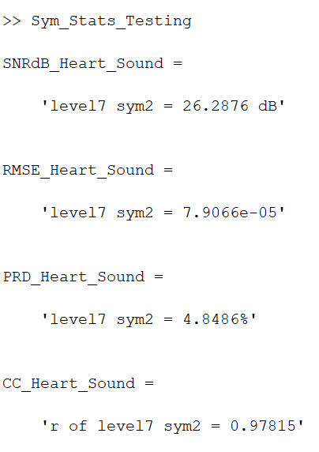

(d) SYM 2 LEVEL 7 SCATTER PLOT RESULT

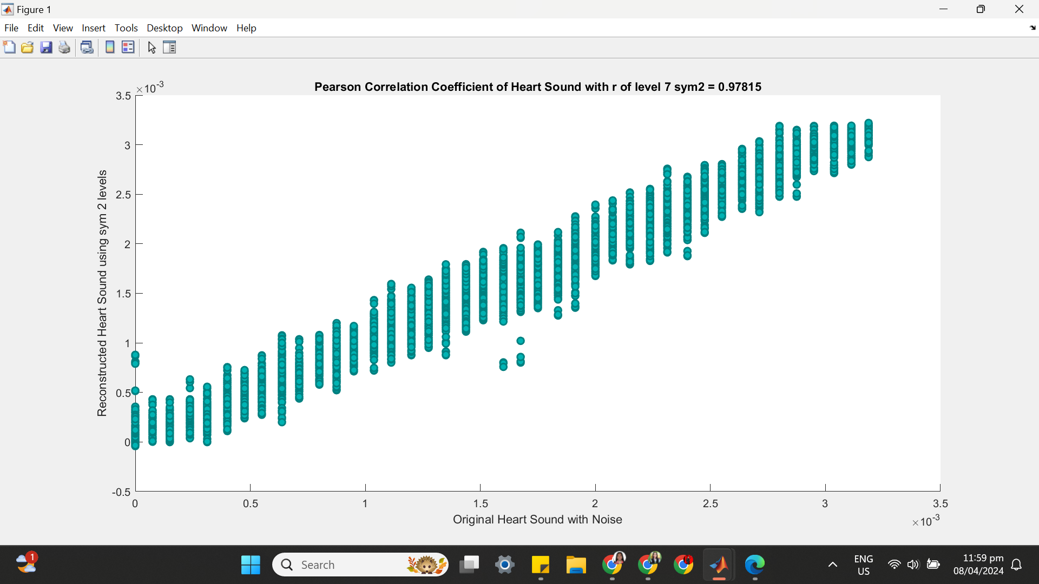

**==================================================================**

**SYM 3**

| **SYM 3** | **No of Delay** | **SNRdB_Heart_Sound** | **RMSE_Heart _Sound** | **PRD_Heart _Sound** | **CC_Heart**  **_Sound** |
| --- | --- | --- | --- | --- | --- |
| Level 2 | 41 | 24.4115 dB | 9.8182e-05 | 6.0176% | 0.96574 |
| Level 3 | 74 | 24.6729 dB | 9.6593e-05 | 5.8392% | 0.96736 |
| Level 4 | 125 | 26.0389 dB | 8.2548e-05 | 4.9895% | 0.97613 |
| Level 5 | 156 | 26.1332 dB | 8.0528e-05 | 4.9356% | 0.97698 |
| Level 6 | 187 | 26.3368 dB | 7.9716e-05 | 4.8213% | 0.97773 |
| Level 7 | 218 | 26.3495 dB | 7.9584e-05 | 4.8142% | 0.97782 |

**++++++++++++++++++++++++++++++++++++++++++++++++++++++++++++++++++**

**(1) SYM 3 LEVEL 2**

(a) SYM 3 LEVEL 2 ARCHITECTURE

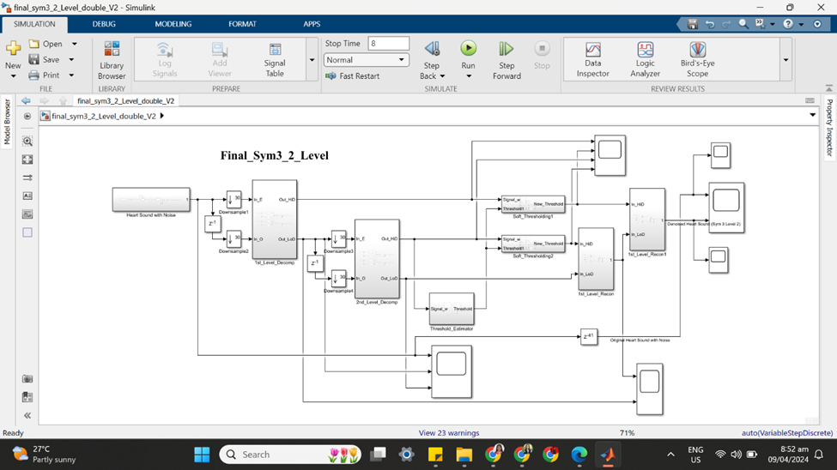

(b) SYM 3 LEVEL 2 SIMULATION RESULT

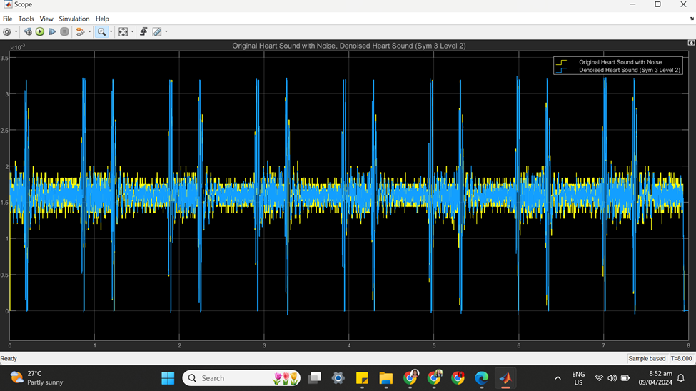

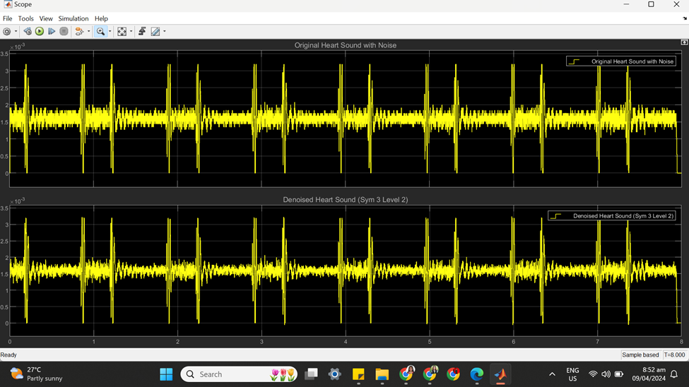

(c) SYM 3 LEVEL 2 STATISTICS RESULT

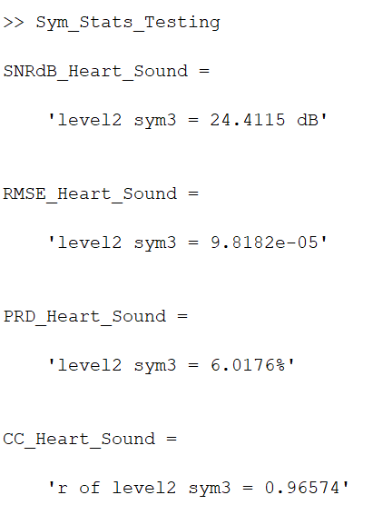

(d) SYM 3 LEVEL 2 SCATTER PLOT RESULT

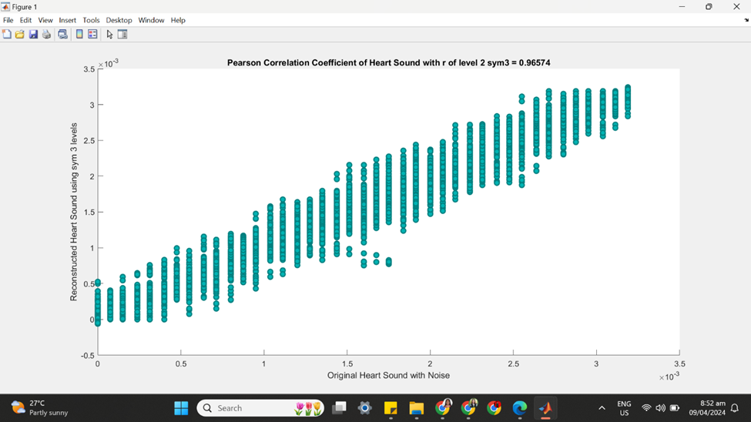

**++++++++++++++++++++++++++++++++++++++++++++++++++++++++++++++++++**

**(2) SYM 3 LEVEL 3**

(a) SYM 3 LEVEL 3 ARCHITECTURE

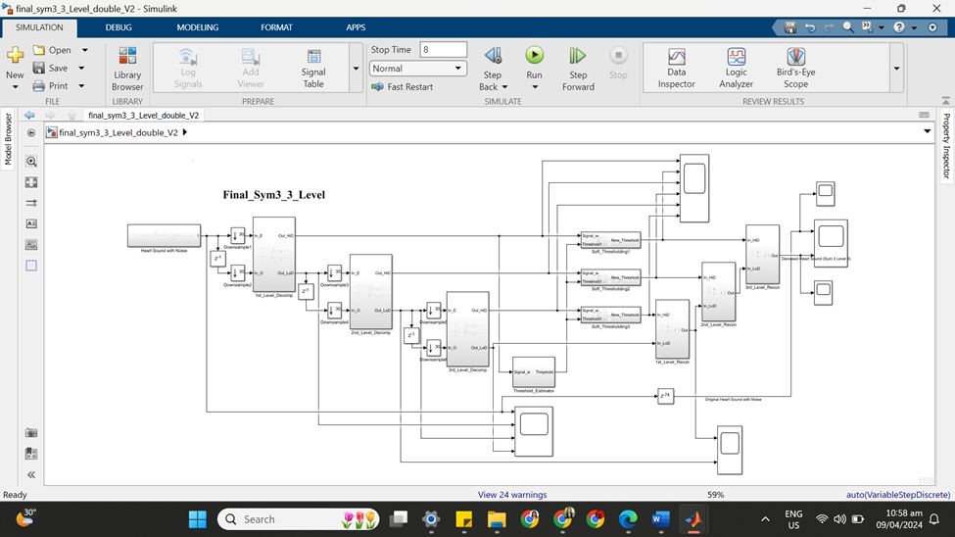

(b) SYM 3 LEVEL 3 SIMULATION RESULT

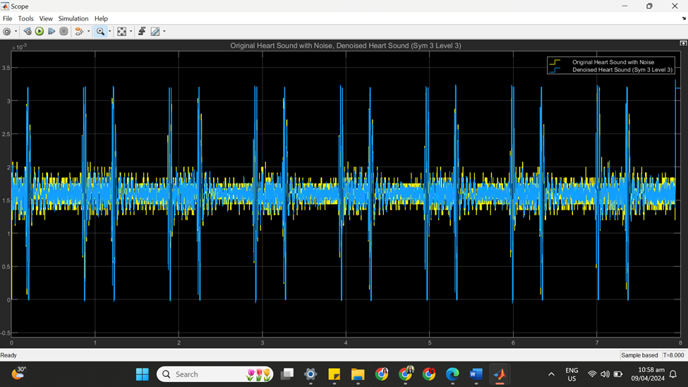

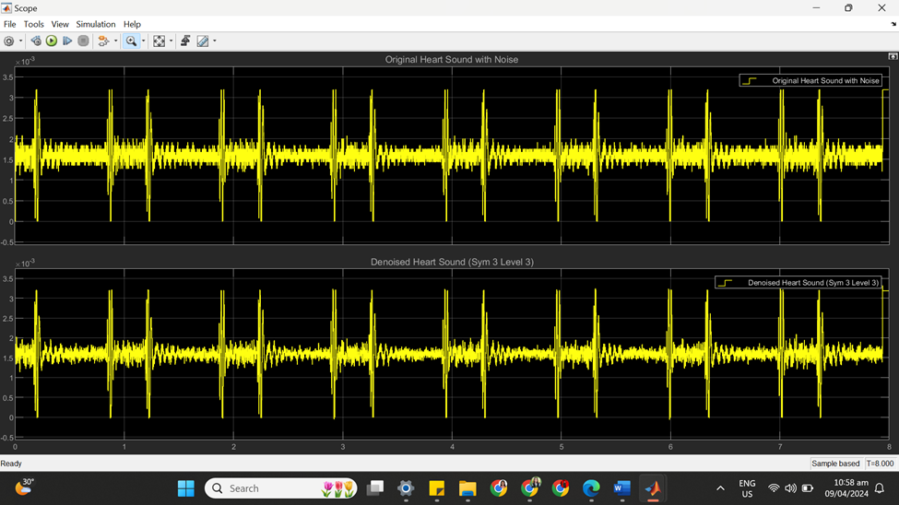

(c) SYM 3 LEVEL 3 STATISTICS RESULT

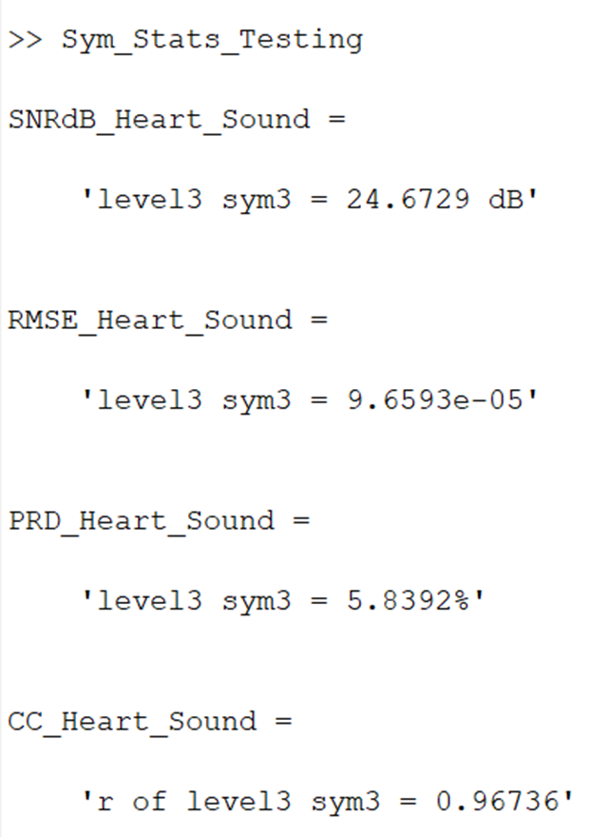

(d) SYM 3 LEVEL 3 SCATTER PLOT RESULT

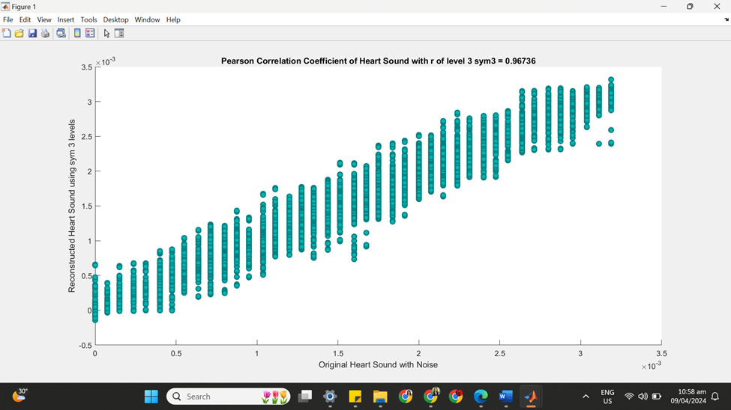

**++++++++++++++++++++++++++++++++++++++++++++++++++++++++++++++++++**

**(3) SYM 3 LEVEL 4**

(a) SYM 3 LEVEL 4 ARCHITECTURE

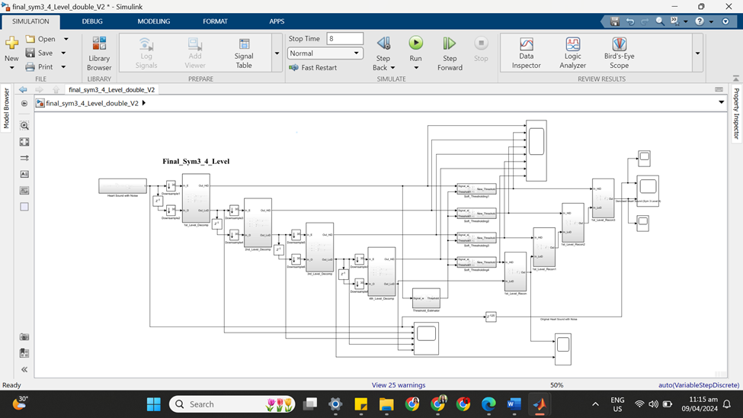

(b) SYM 3 LEVEL 4 SIMULATION RESULT

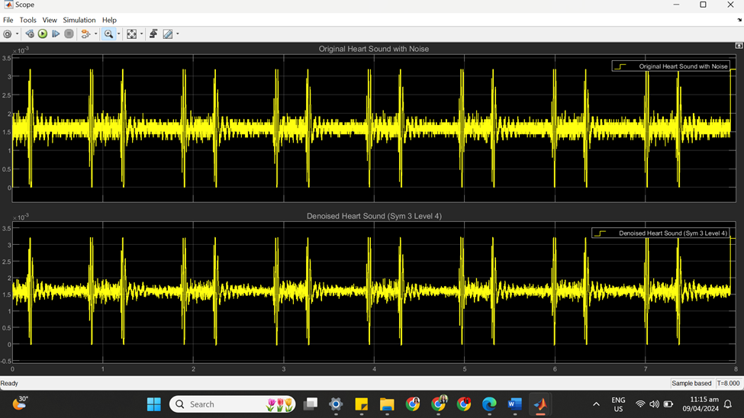

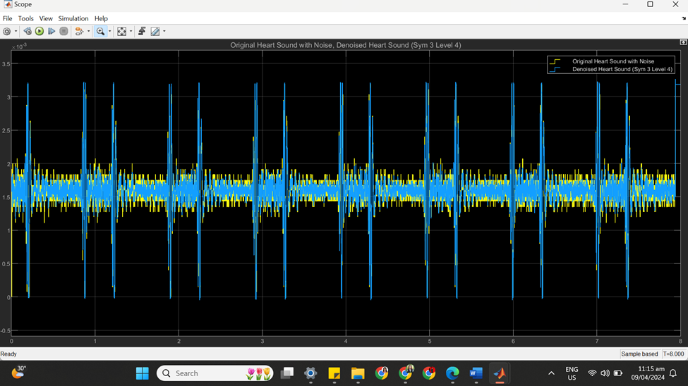

(c) SYM 3 LEVEL 4 STATISTICS RESULT

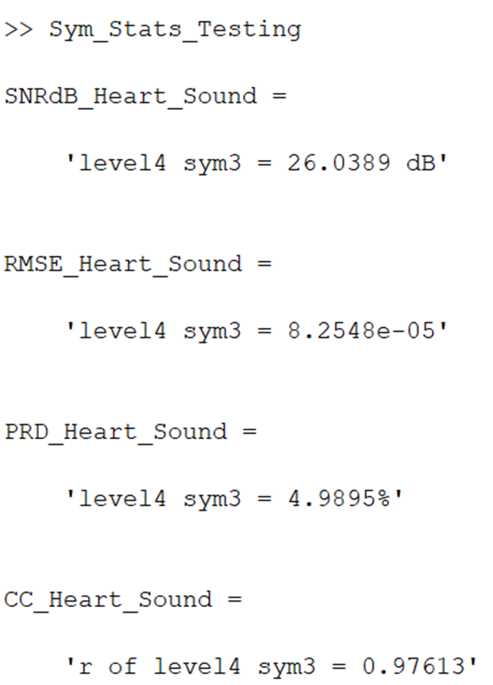

(d) SYM 3 LEVEL 4 SCATTER PLOT RESULT

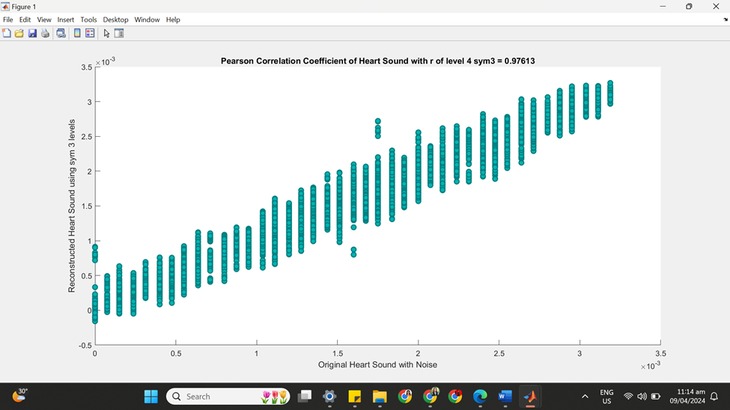

**++++++++++++++++++++++++++++++++++++++++++++++++++++++++++++++++++**

**(4) SYM 3 LEVEL 5**

(a) SYM 3 LEVEL 5 ARCHITECTURE

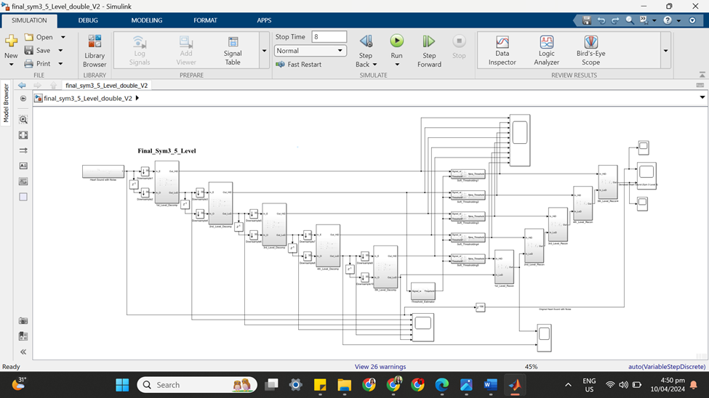

(b) SYM 3 LEVEL 5 SIMULATION RESULT

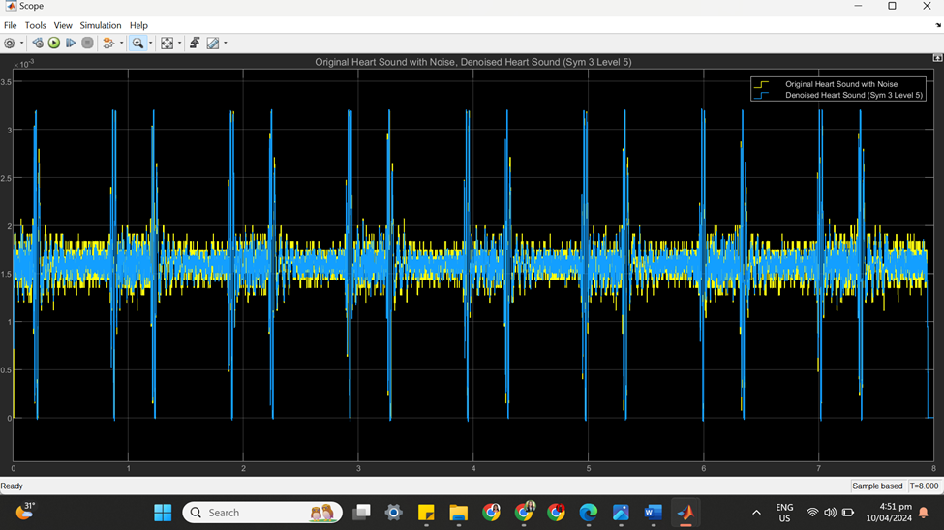

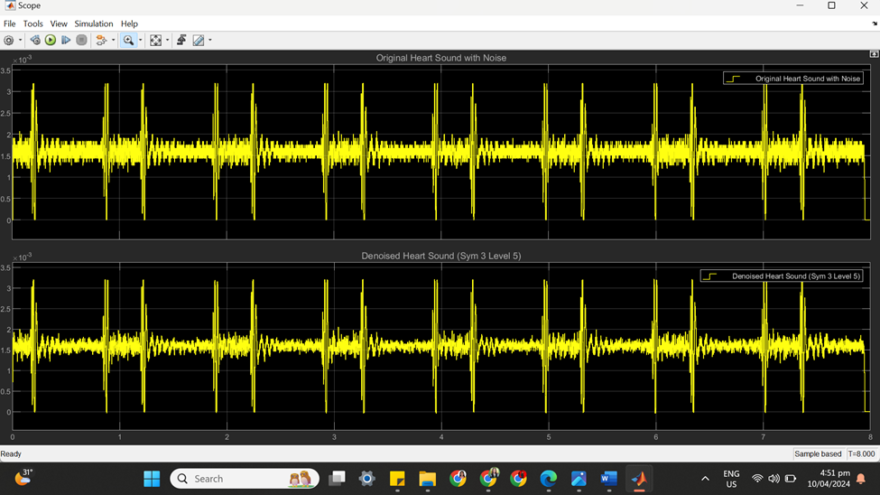

(c) SYM 3 LEVEL 5 STATISTICS RESULT

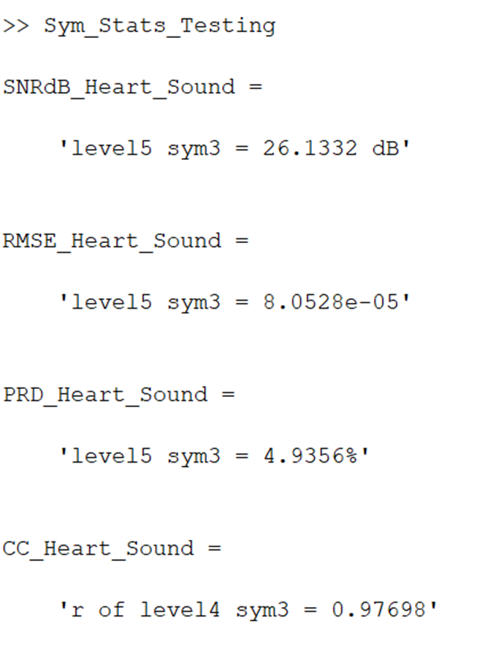

(d) SYM 3 LEVEL 5 SCATTER PLOT RESULT

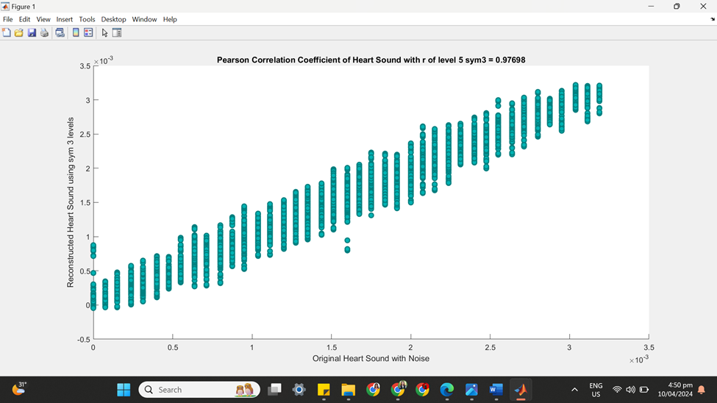

**++++++++++++++++++++++++++++++++++++++++++++++++++++++++++++++++++**

**(5) SYM 3 LEVEL 6**

(a) SYM 3 LEVEL 6 ARCHITECTURE

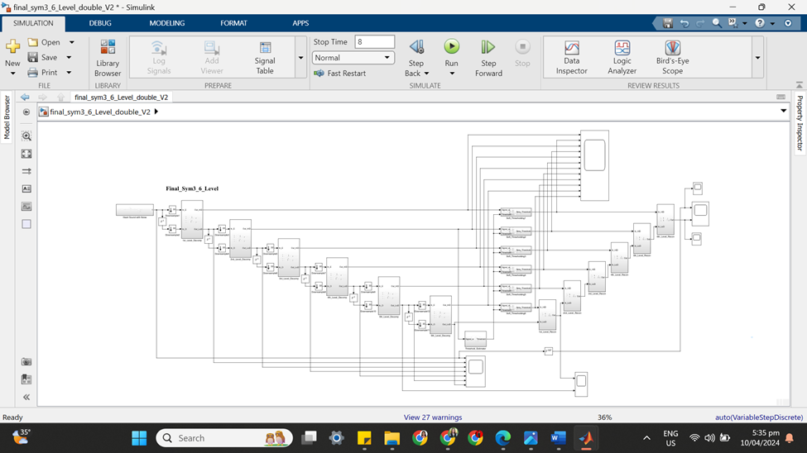

(b) SYM 3 LEVEL 6 SIMULATION RESULT

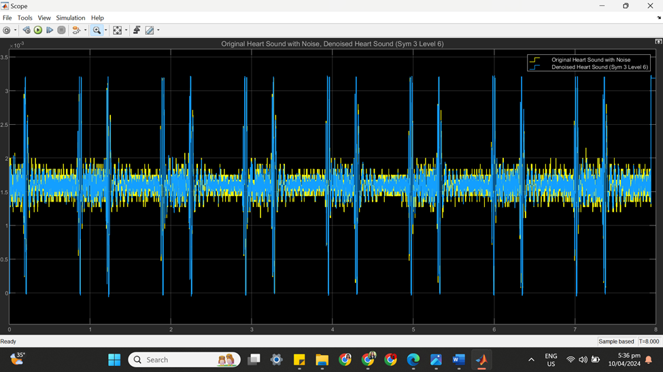

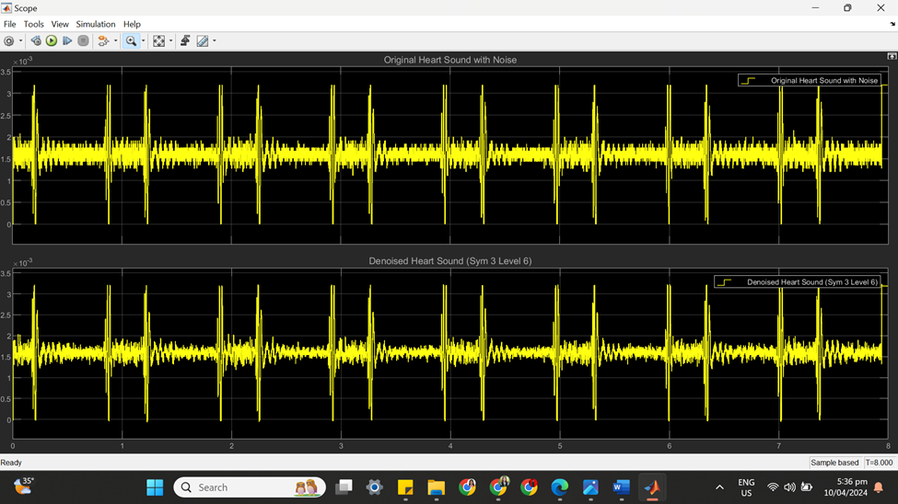

(c) SYM 3 LEVEL 6 STATISTICS RESULT

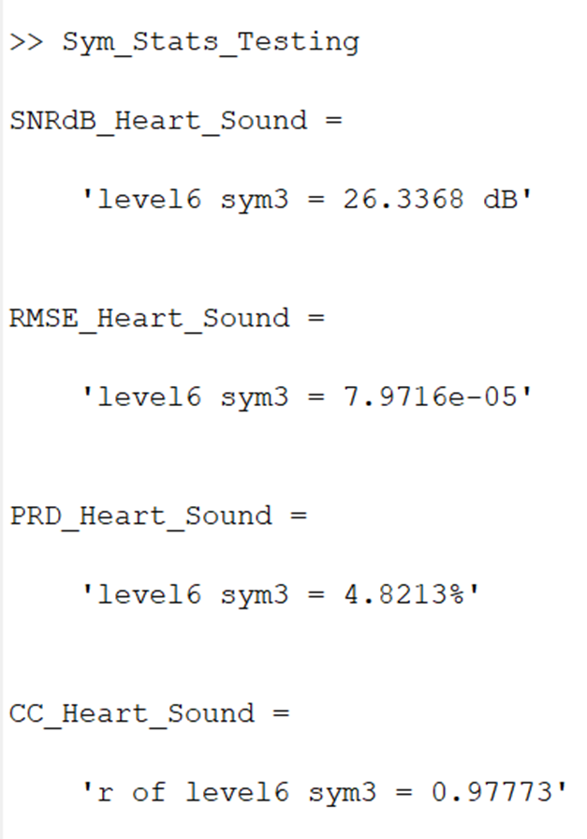

(d) SYM 3 LEVEL 6 SCATTER PLOT RESULT

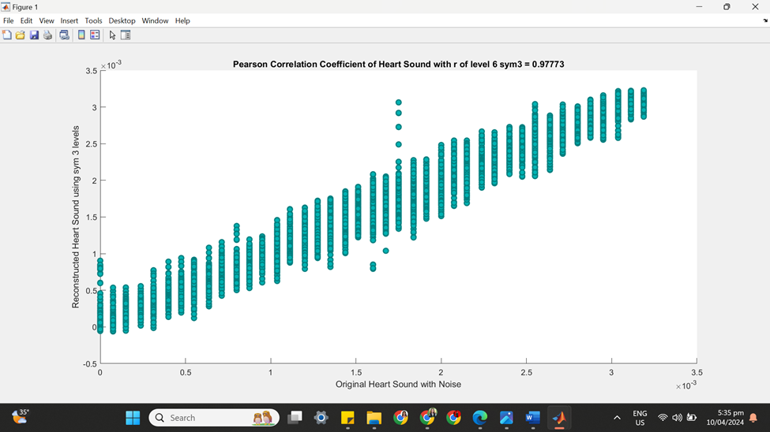

**++++++++++++++++++++++++++++++++++++++++++++++++++++++++++++++++++**

**(6) SYM 3 LEVEL 7**

(a) SYM 3 LEVEL 7 ARCHITECTURE

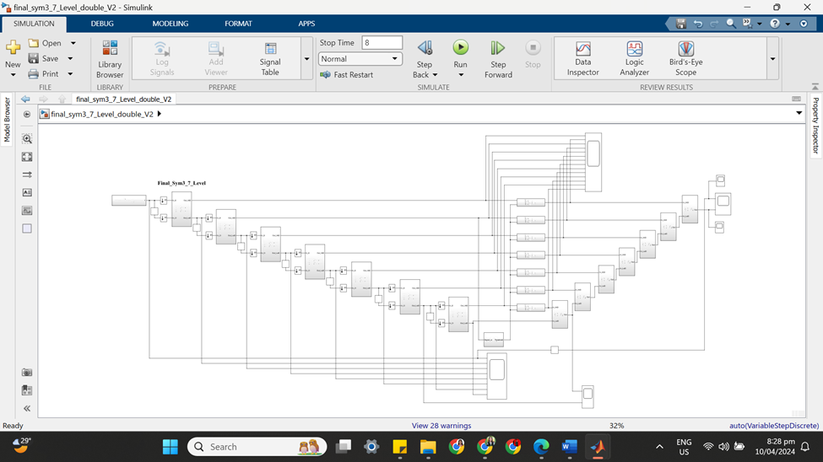

(b) SYM 3 LEVEL 7 SIMULATION RESULT

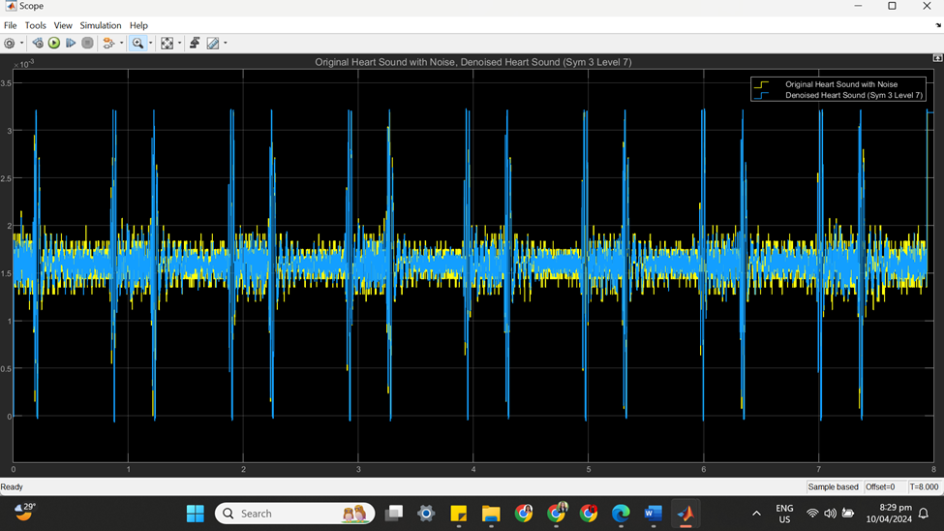

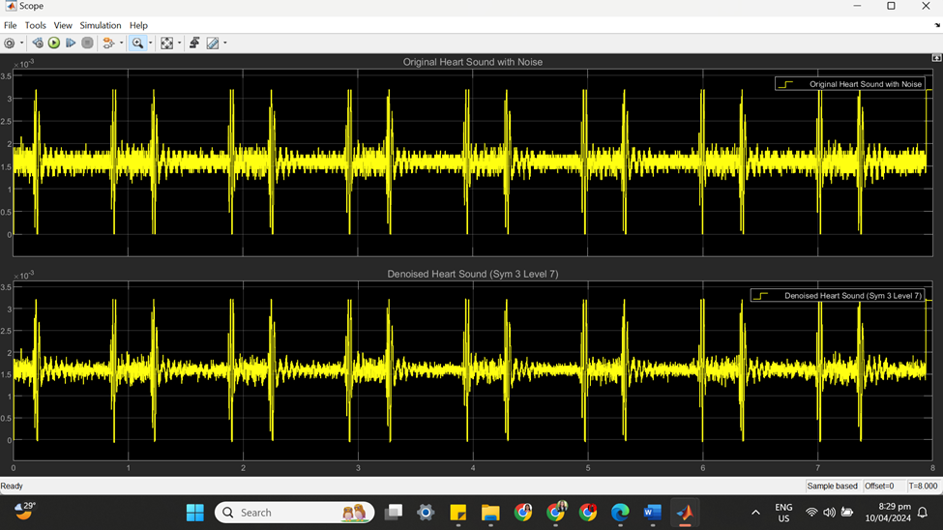

(c) SYM 3 LEVEL 7 STATISTICS RESULT

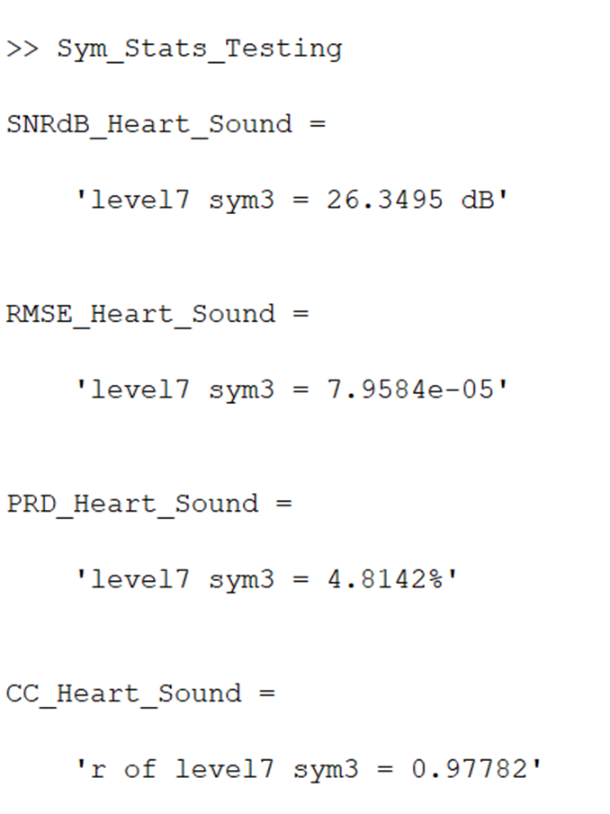

(d) SYM 3 LEVEL 7 SCATTER PLOT RESULT

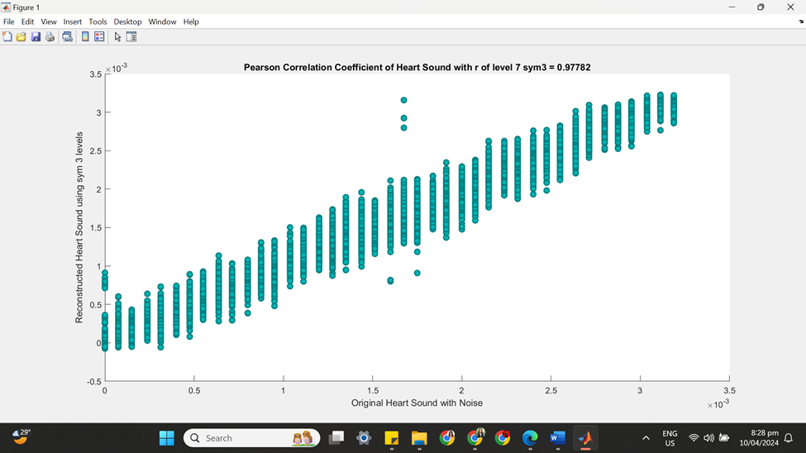

**==================================================================**

**SYM 4**

| **SYM 3** | **No of Delay** | **SNRdB_Heart _Sound** | **RMSE_Heart_Sound** | **PRD_Heart_Sound** | **CC_Heart**  **_Sound** |
| --- | --- | --- | --- | --- | --- |
| Level 2 | 43 | 23.7969 dB | 0.00010538 | 6.4589% | 0.96052 |
| Level 3 | 80 | 24.2432 dB | 0.00010149 | 6.1354% | 0.96396 |
| **Level 4** | 117 | 24.5436 dB | 9.7999e-05 | 5.9268% | 0.96632 |
| **Level 5** | 154 | 24.6968 dB | 9.501e-05 | 5.8232% | 0.96792 |
| Level 6 | 188 | 25.0668 dB | 9.2293e-05 | 5.5804% | 0.97015 |
| Level 7 | 234 | 26.4221 dB | 7.8948e-05 | 4.7741% | 0.97821 |

**++++++++++++++++++++++++++++++++++++++++++++++++++++++++++++++++++**

**(1) SYM 4 LEVEL 2**

(a) SYM 4 LEVEL 2 ARCHITECTURE

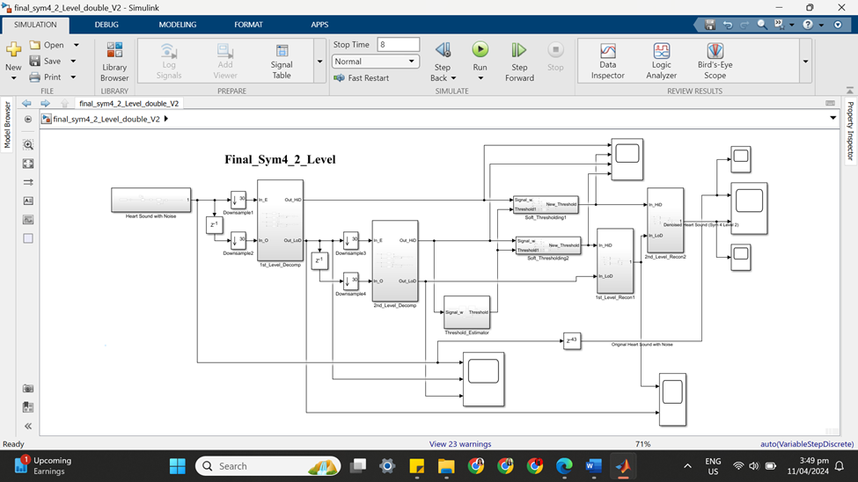

(b) SYM 4 LEVEL 2 SIMULATION RESULT

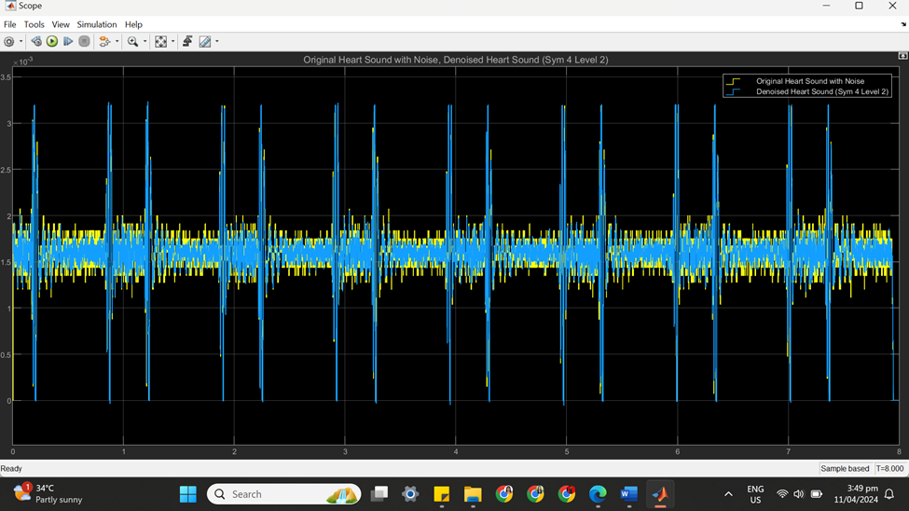

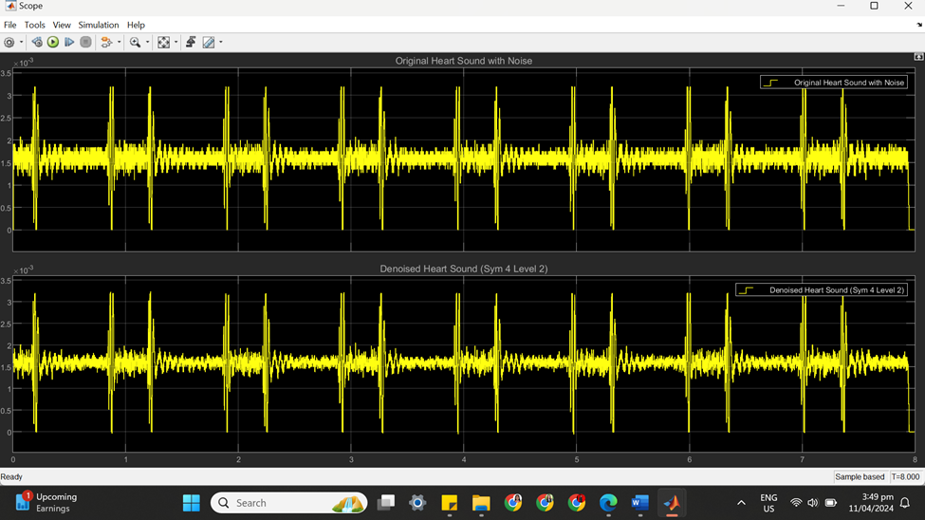

(c) SYM 4 LEVEL 2 STATISTICS RESULT

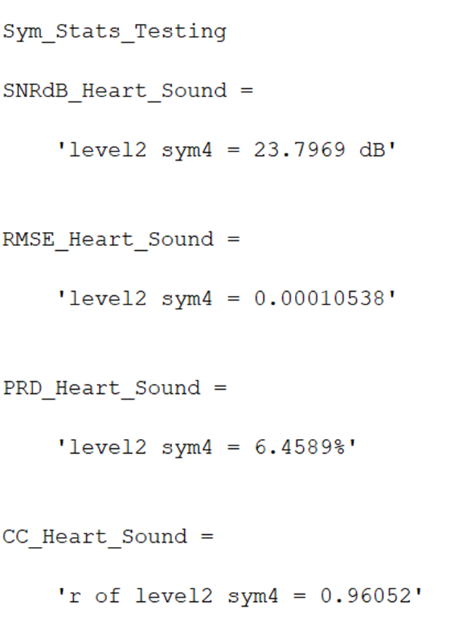

(d) SYM 4 LEVEL 2 SCATTER PLOT RESULT

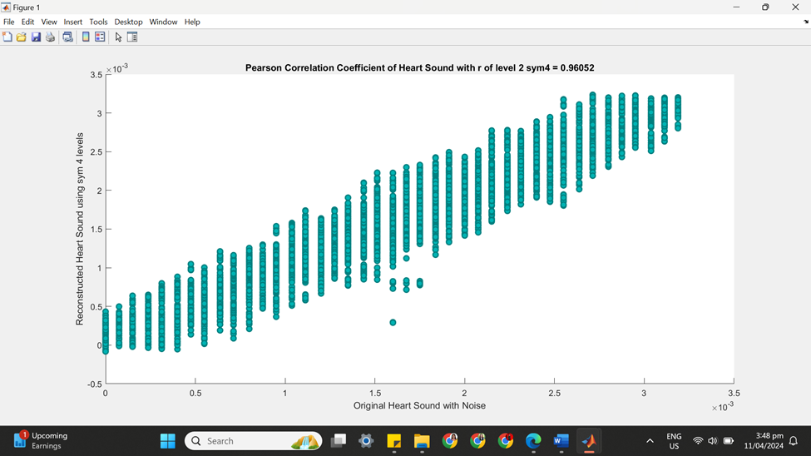

**++++++++++++++++++++++++++++++++++++++++++++++++++++++++++++++++++**

**(2) SYM 4 LEVEL 3**

(a) SYM 4 LEVEL 3 ARCHITECTURE

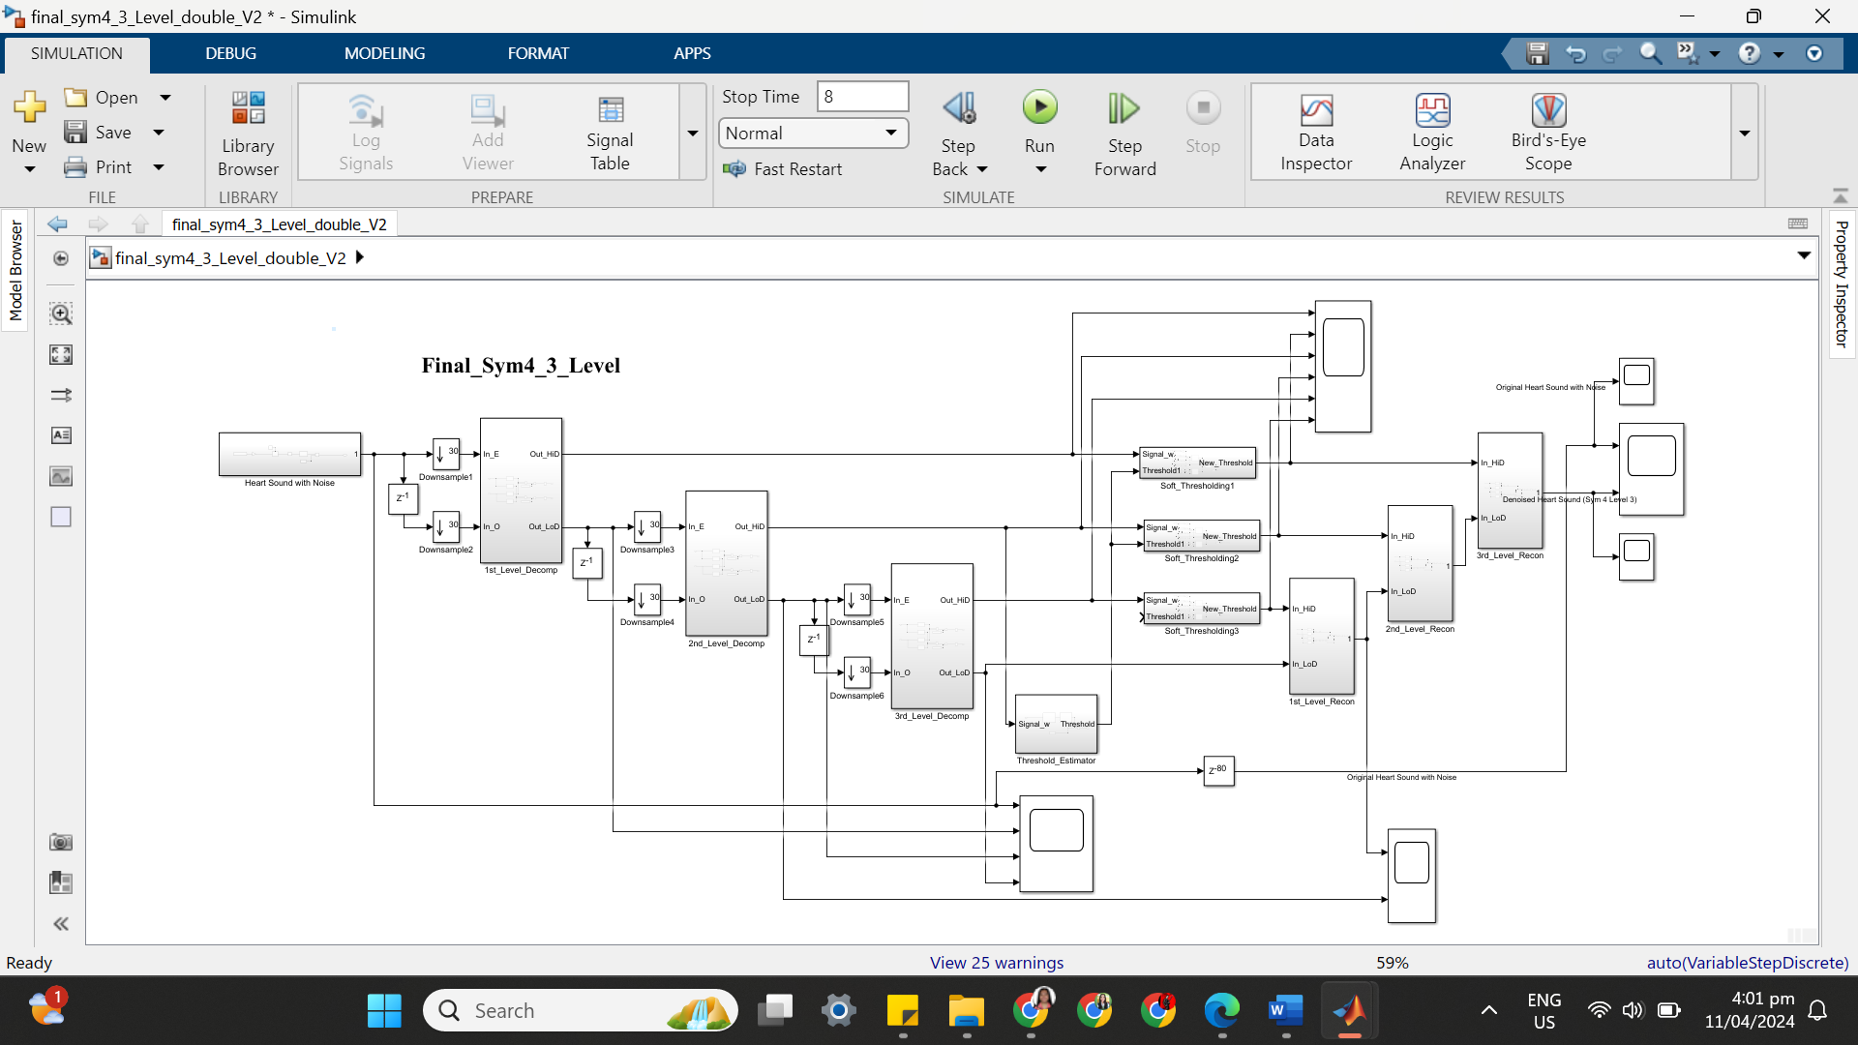

(b) SYM 4 LEVEL 3 SIMULATION RESULT

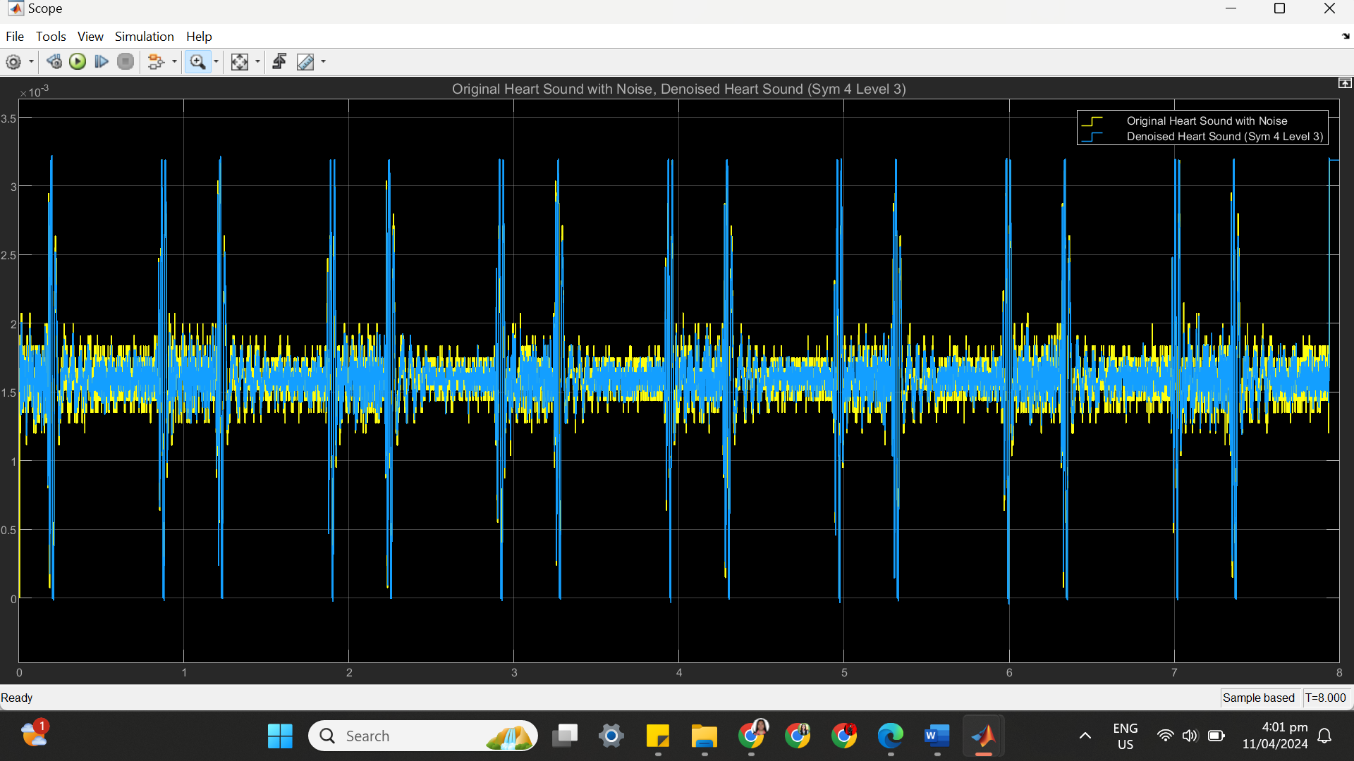

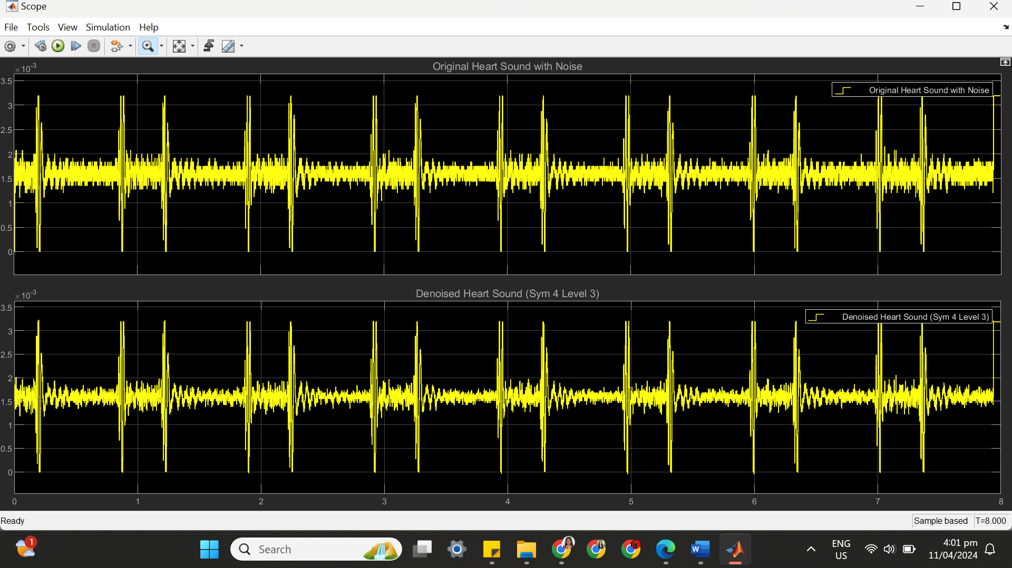

(c) SYM 4 LEVEL 3 STATISTICS RESULT

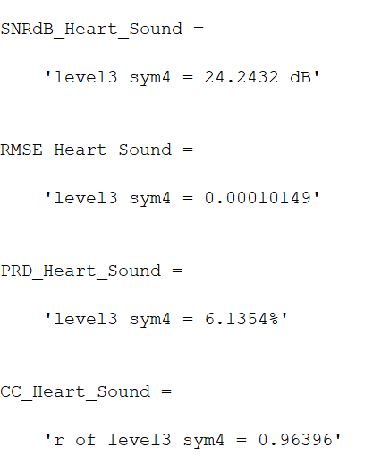

(d) SYM 4 LEVEL 3 SCATTER PLOT RESULT

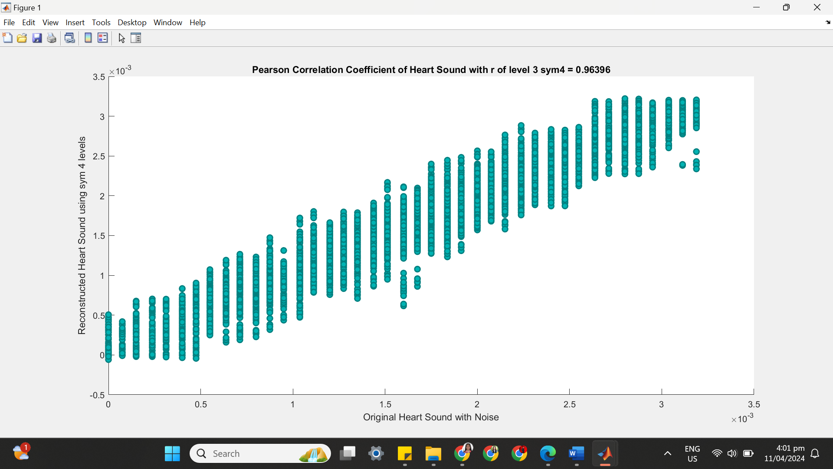

**++++++++++++++++++++++++++++++++++++++++++++++++++++++++++++++++++**

**(3) SYM 4 LEVEL 4**

(a) SYM 4 LEVEL 4 ARCHITECTURE

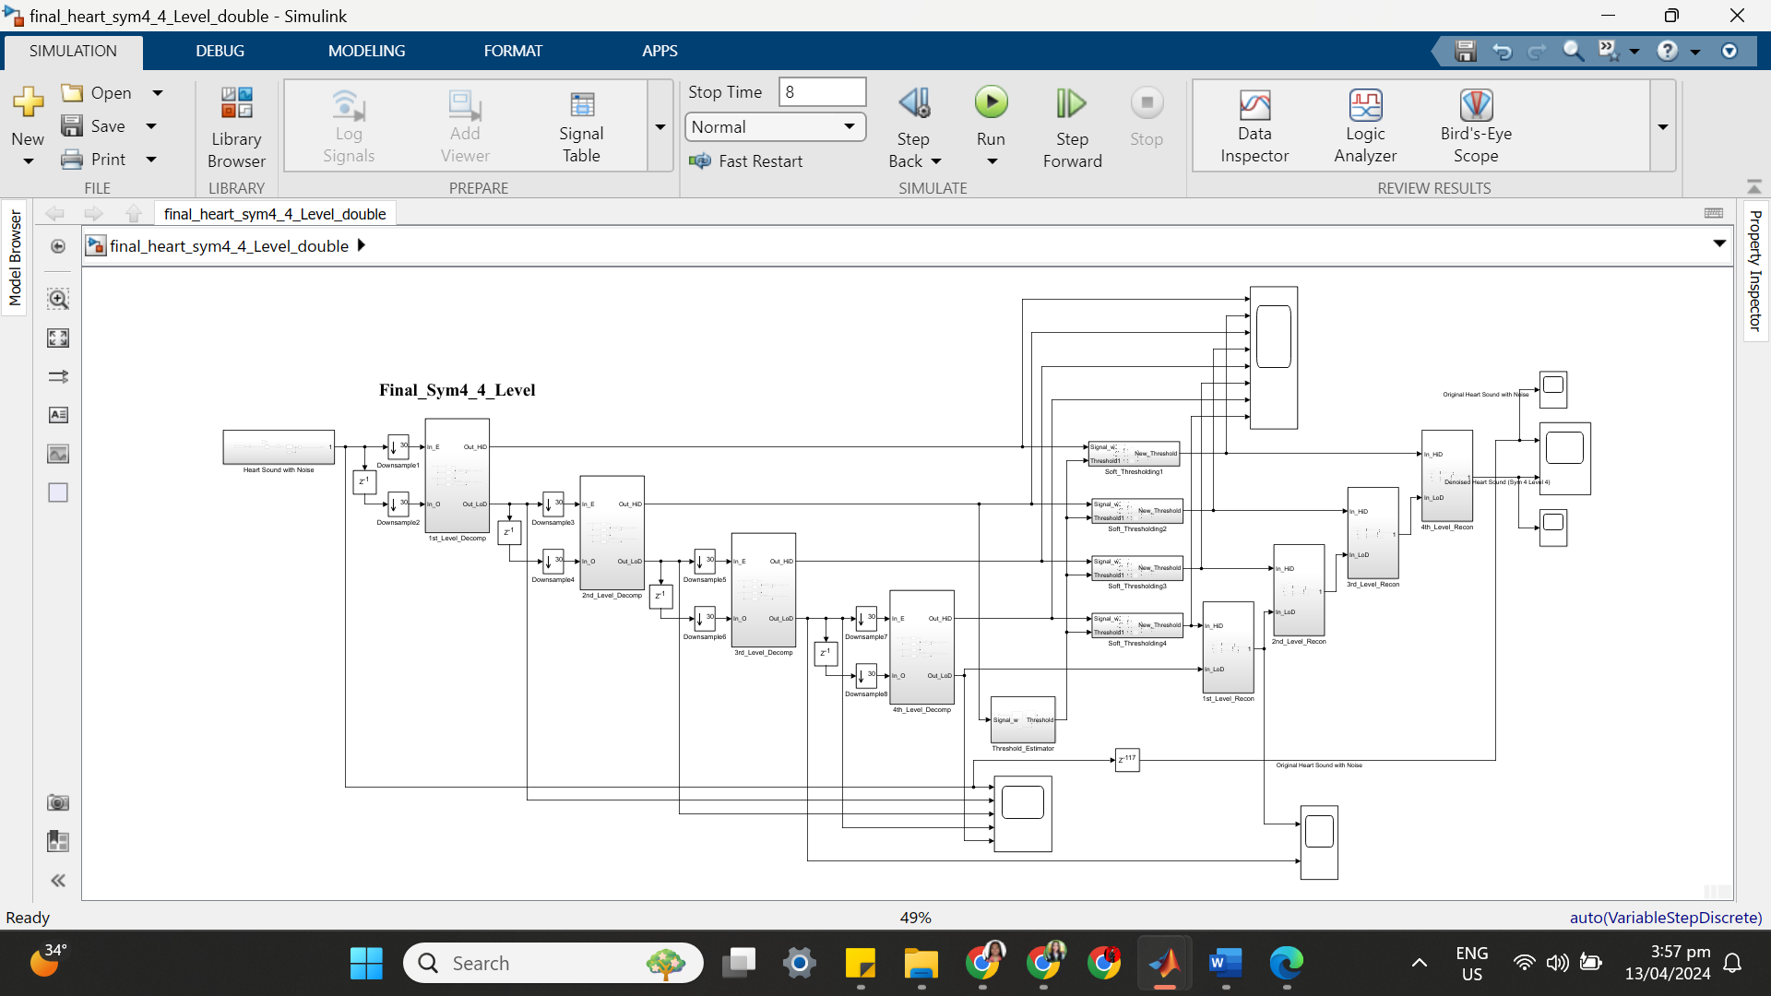

(b) SYM 4 LEVEL 4 SIMULATION RESULT

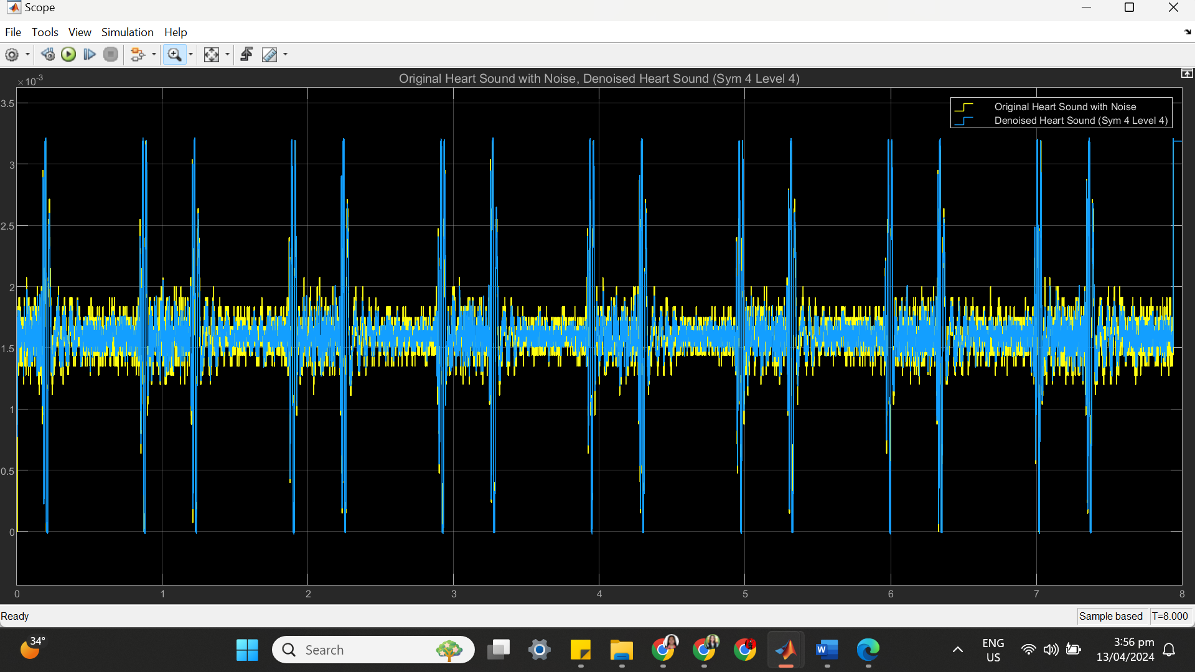

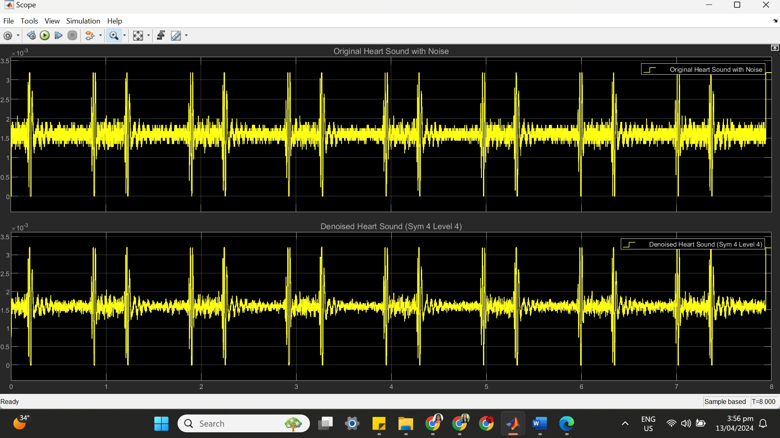

(c) SYM 4 LEVEL 4 STATISTICS RESULT

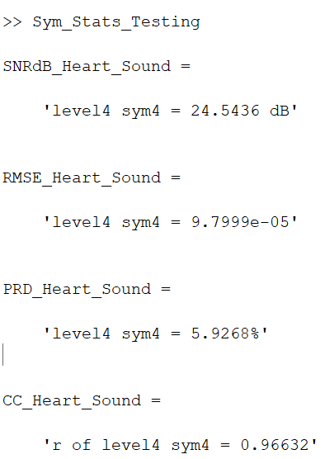

(d) SYM 4 LEVEL 4 SCATTER PLOT RESULT

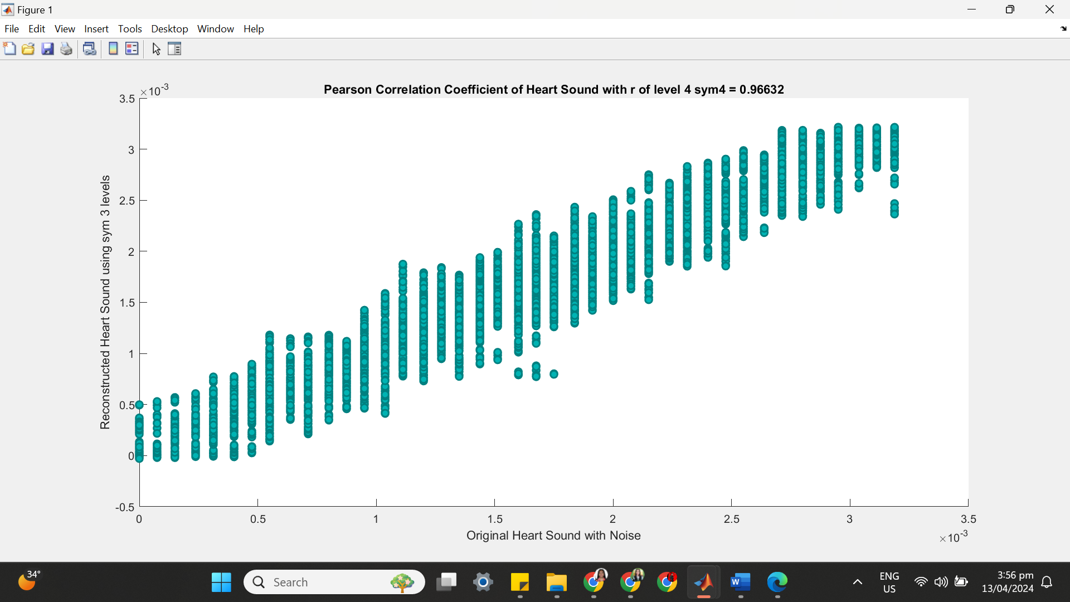

**++++++++++++++++++++++++++++++++++++++++++++++++++++++++++++++++++**

**(4) SYM 4 LEVEL 5**

(a) SYM 4 LEVEL 5 ARCHITECTURE

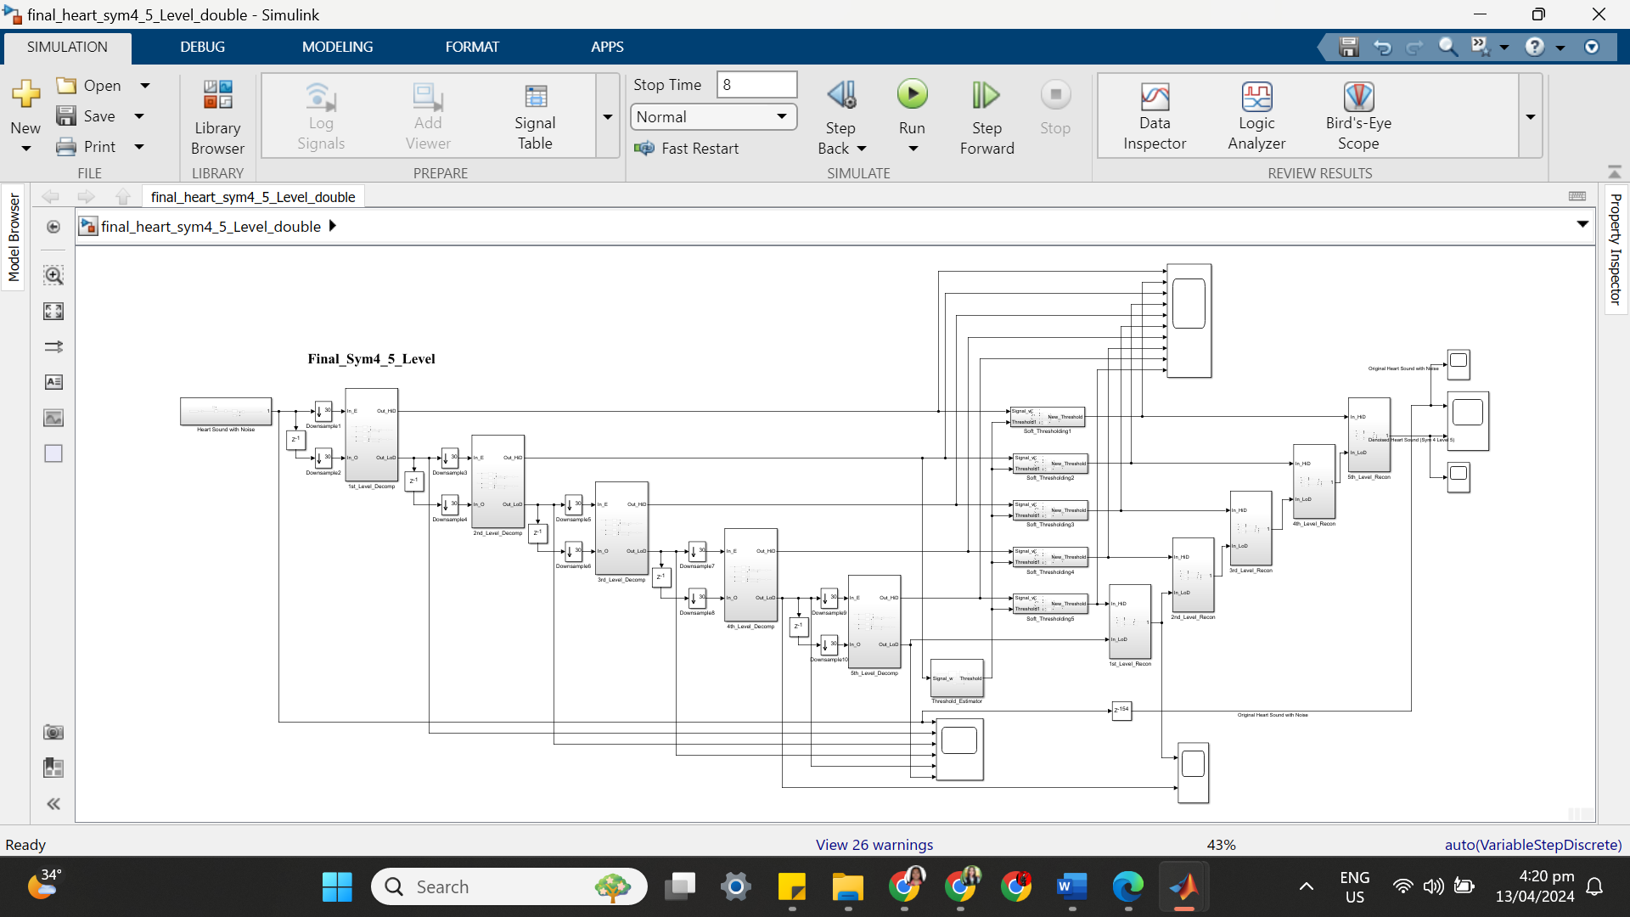

(b) SYM 4 LEVEL 5 SIMULATION RESULT

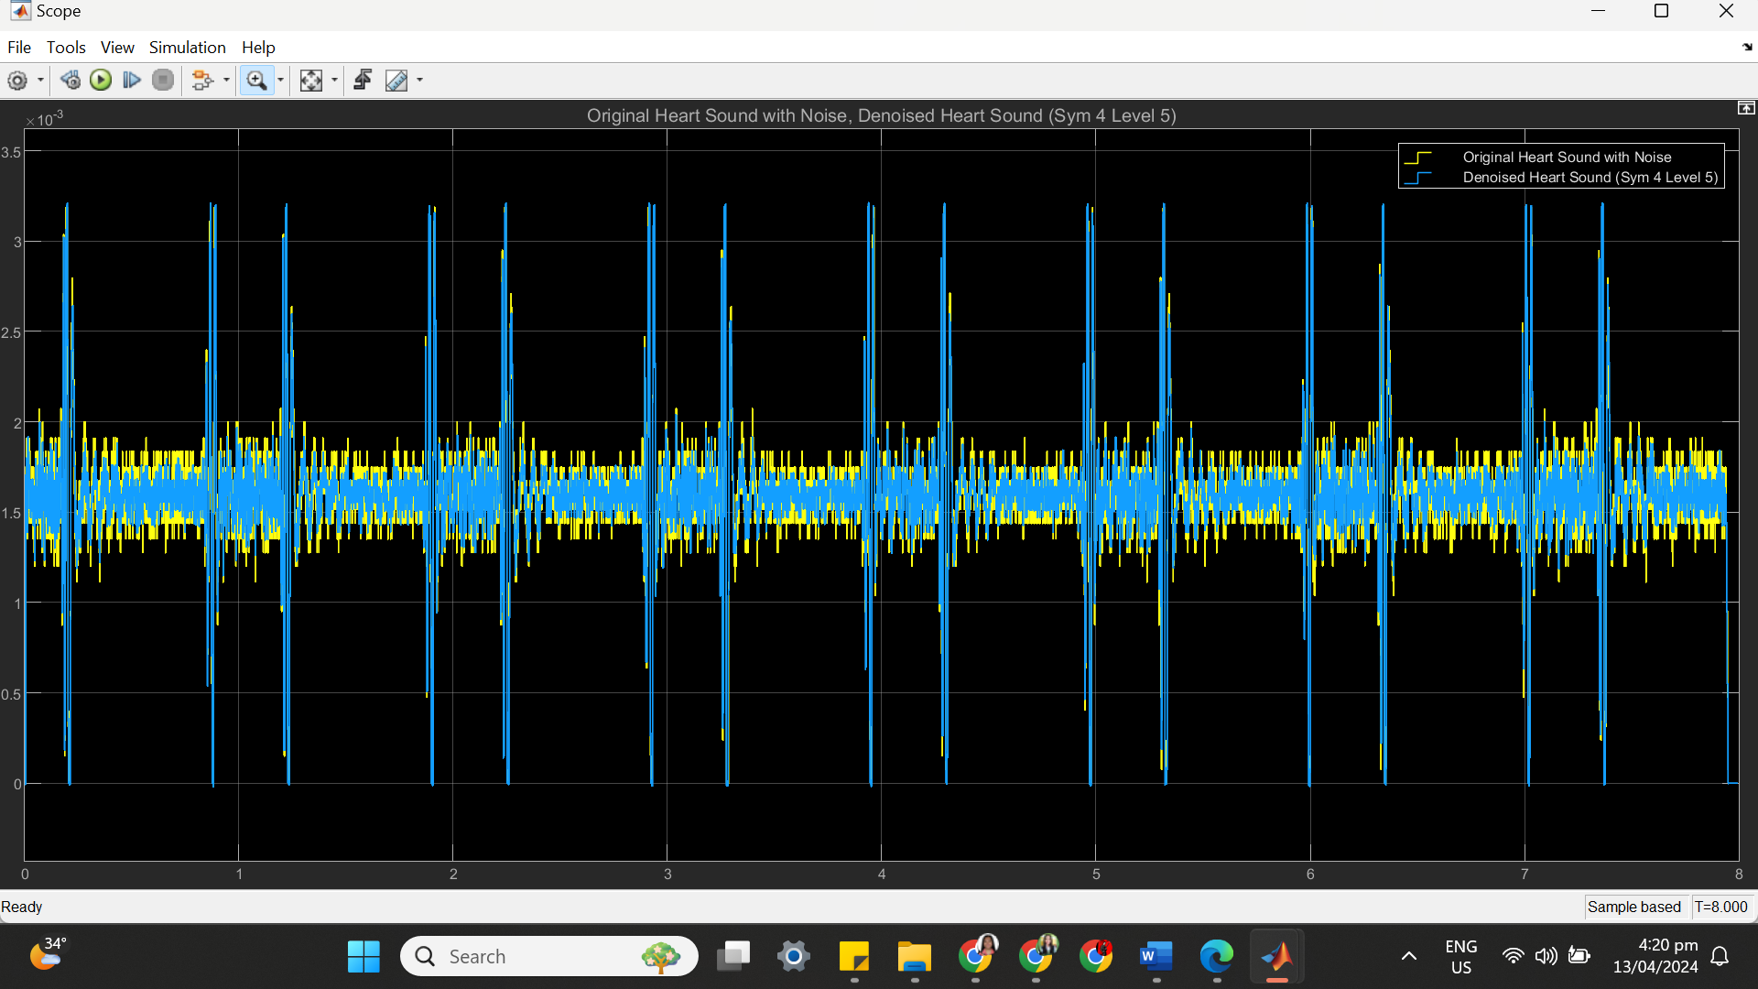

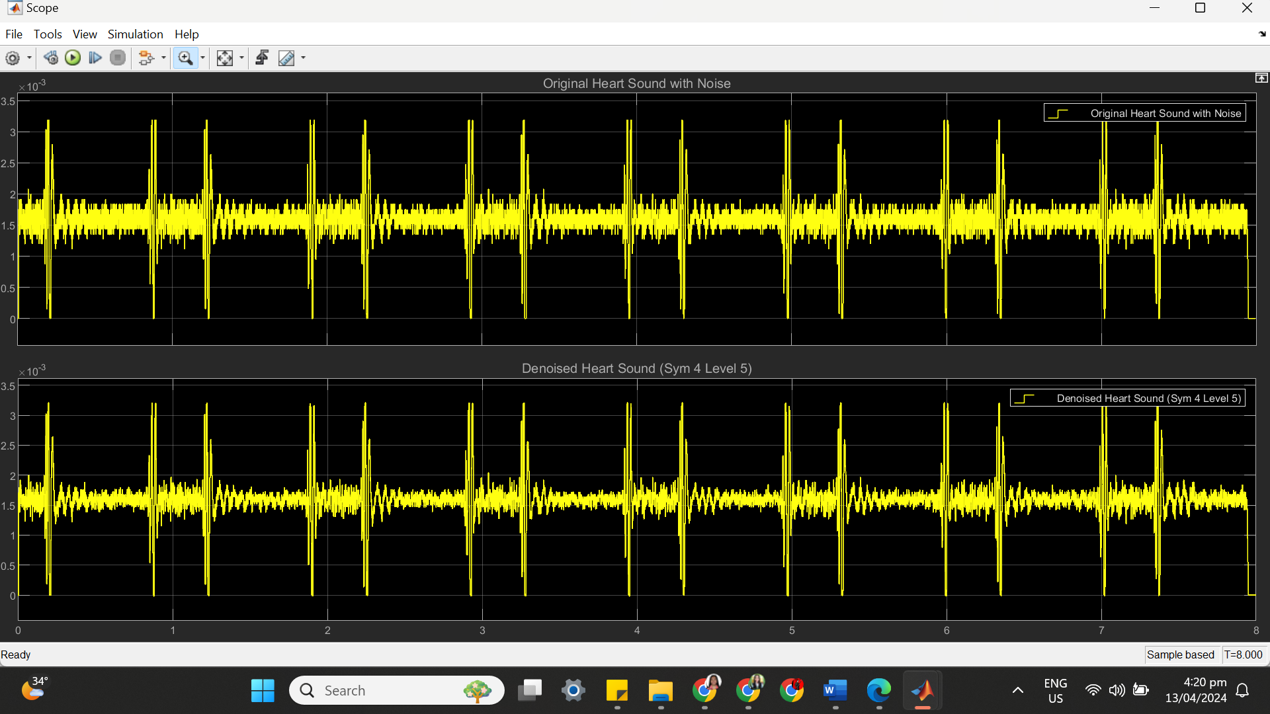

(c) SYM 4 LEVEL 5 STATISTICS RESULT

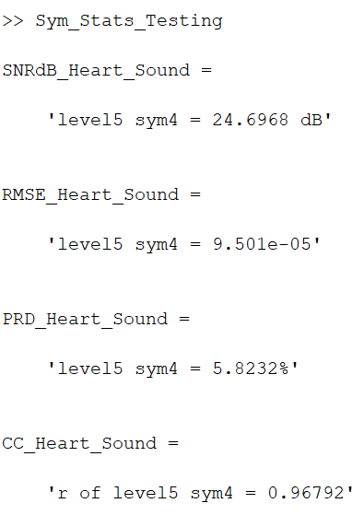

(d) SYM 4 LEVEL 5 SCATTER PLOT RESULT

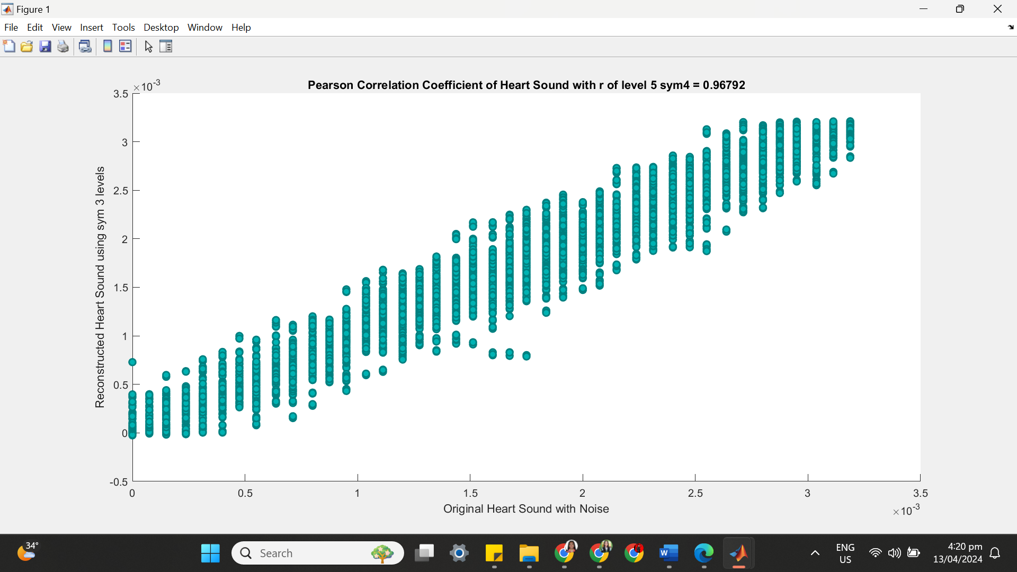

**++++++++++++++++++++++++++++++++++++++++++++++++++++++++++++++++++**

**(5) SYM 4 LEVEL 6**

(a) SYM 4 LEVEL 6 ARCHITECTURE

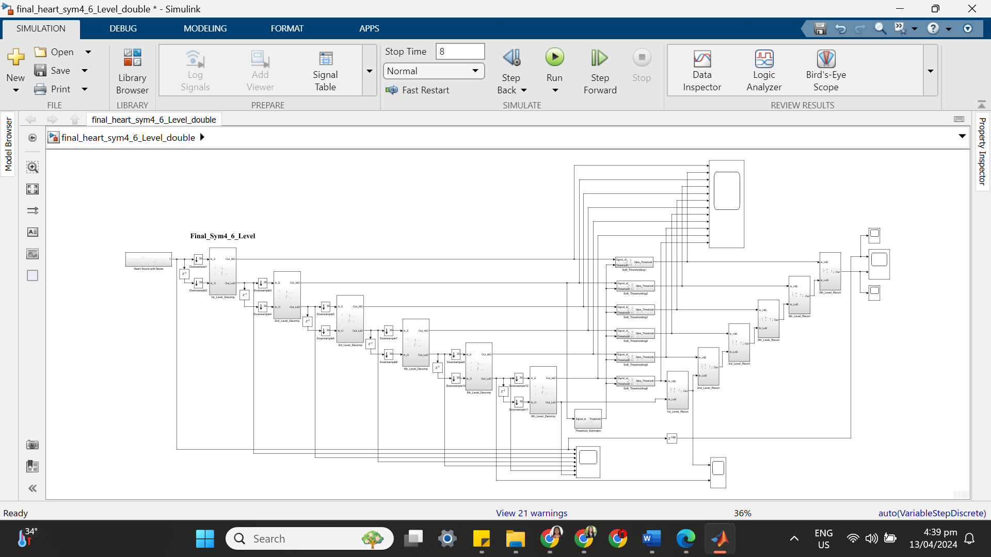

(b) SYM 4 LEVEL 6 SIMULATION RESULT

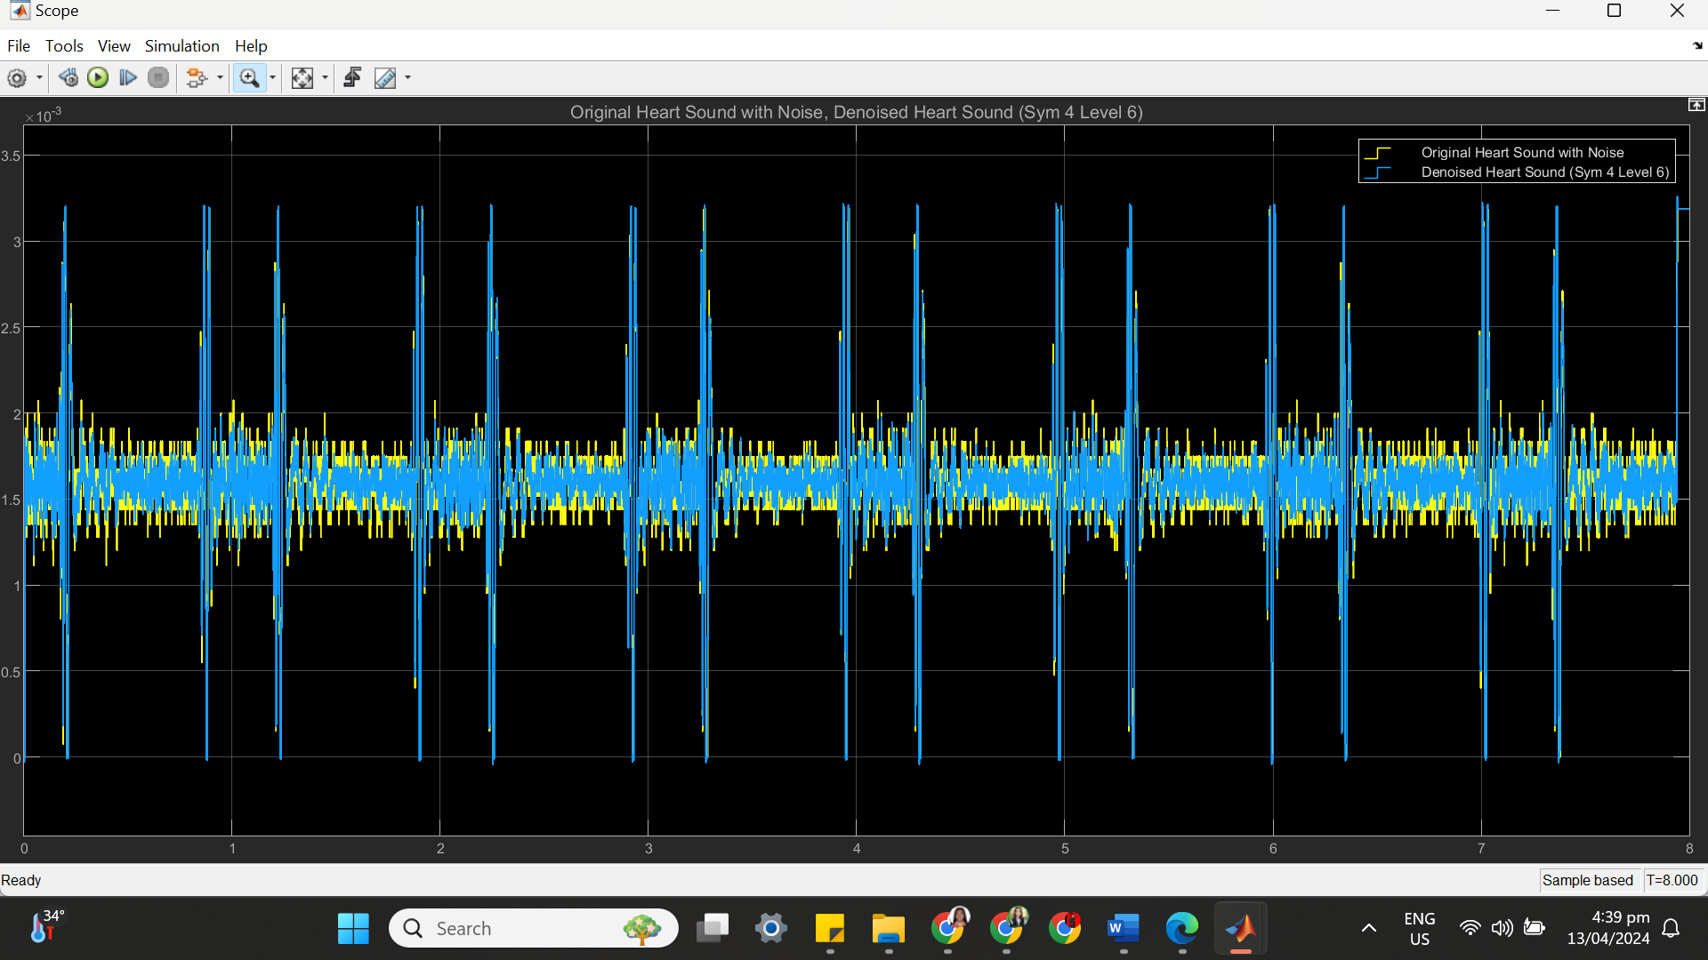

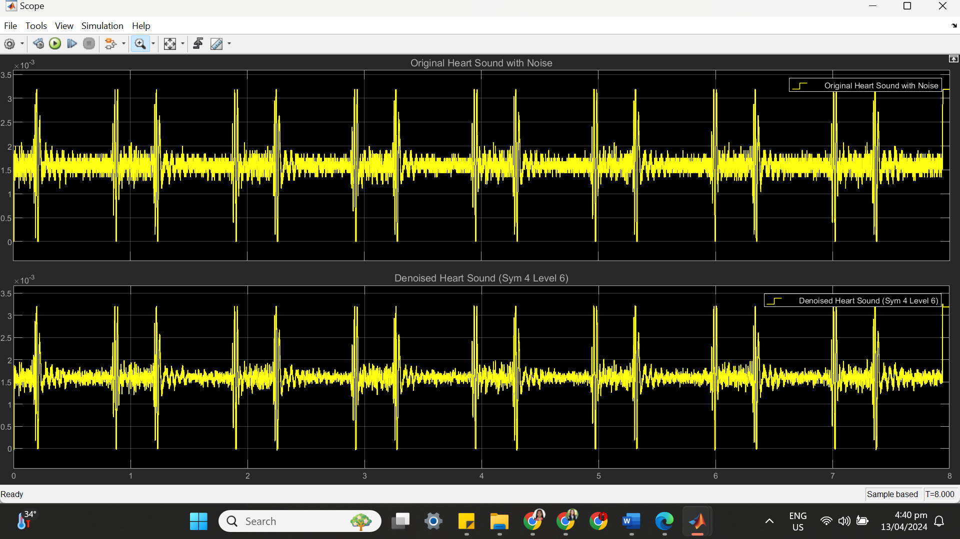

(c) SYM 4 LEVEL 6 STATISTICS RESULT

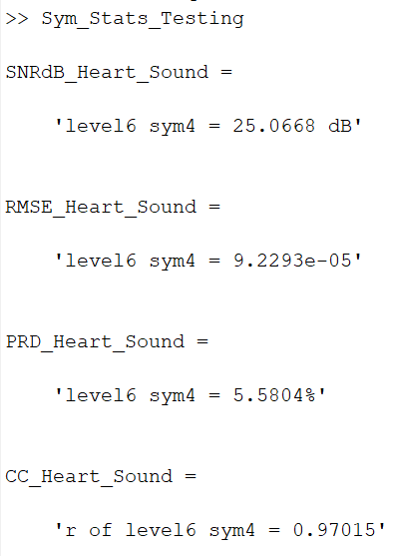

(d) SYM 4 LEVEL 6 SCATTER PLOT RESULT

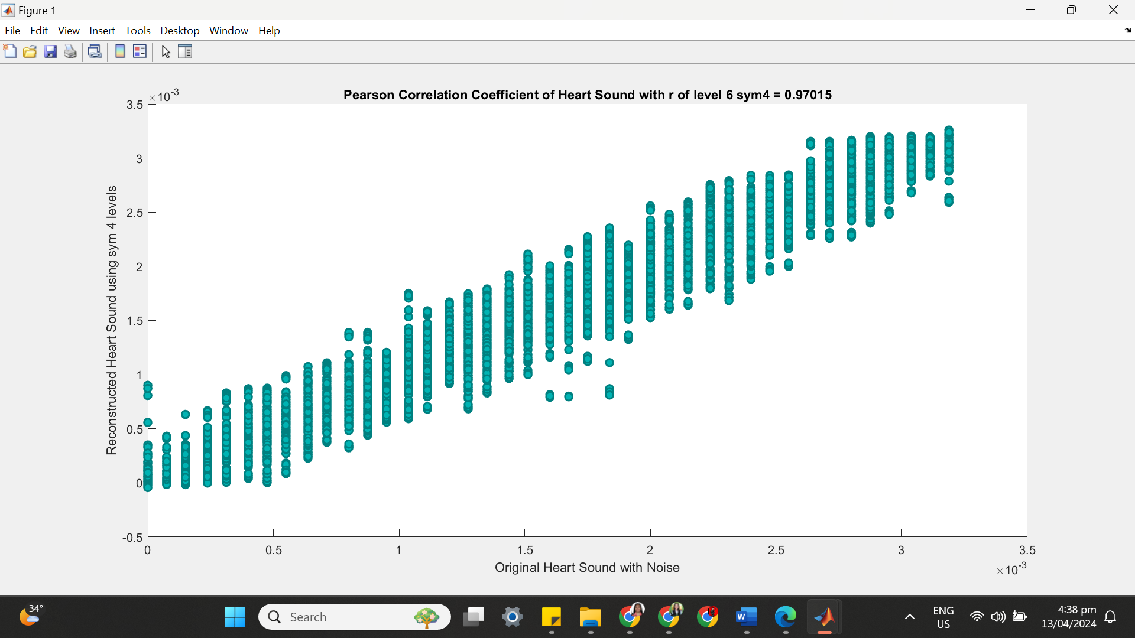

**++++++++++++++++++++++++++++++++++++++++++++++++++++++++++++++++++**

**(6) SYM 4 LEVEL 7**

(a) SYM 4 LEVEL 7 ARCHITECTURE

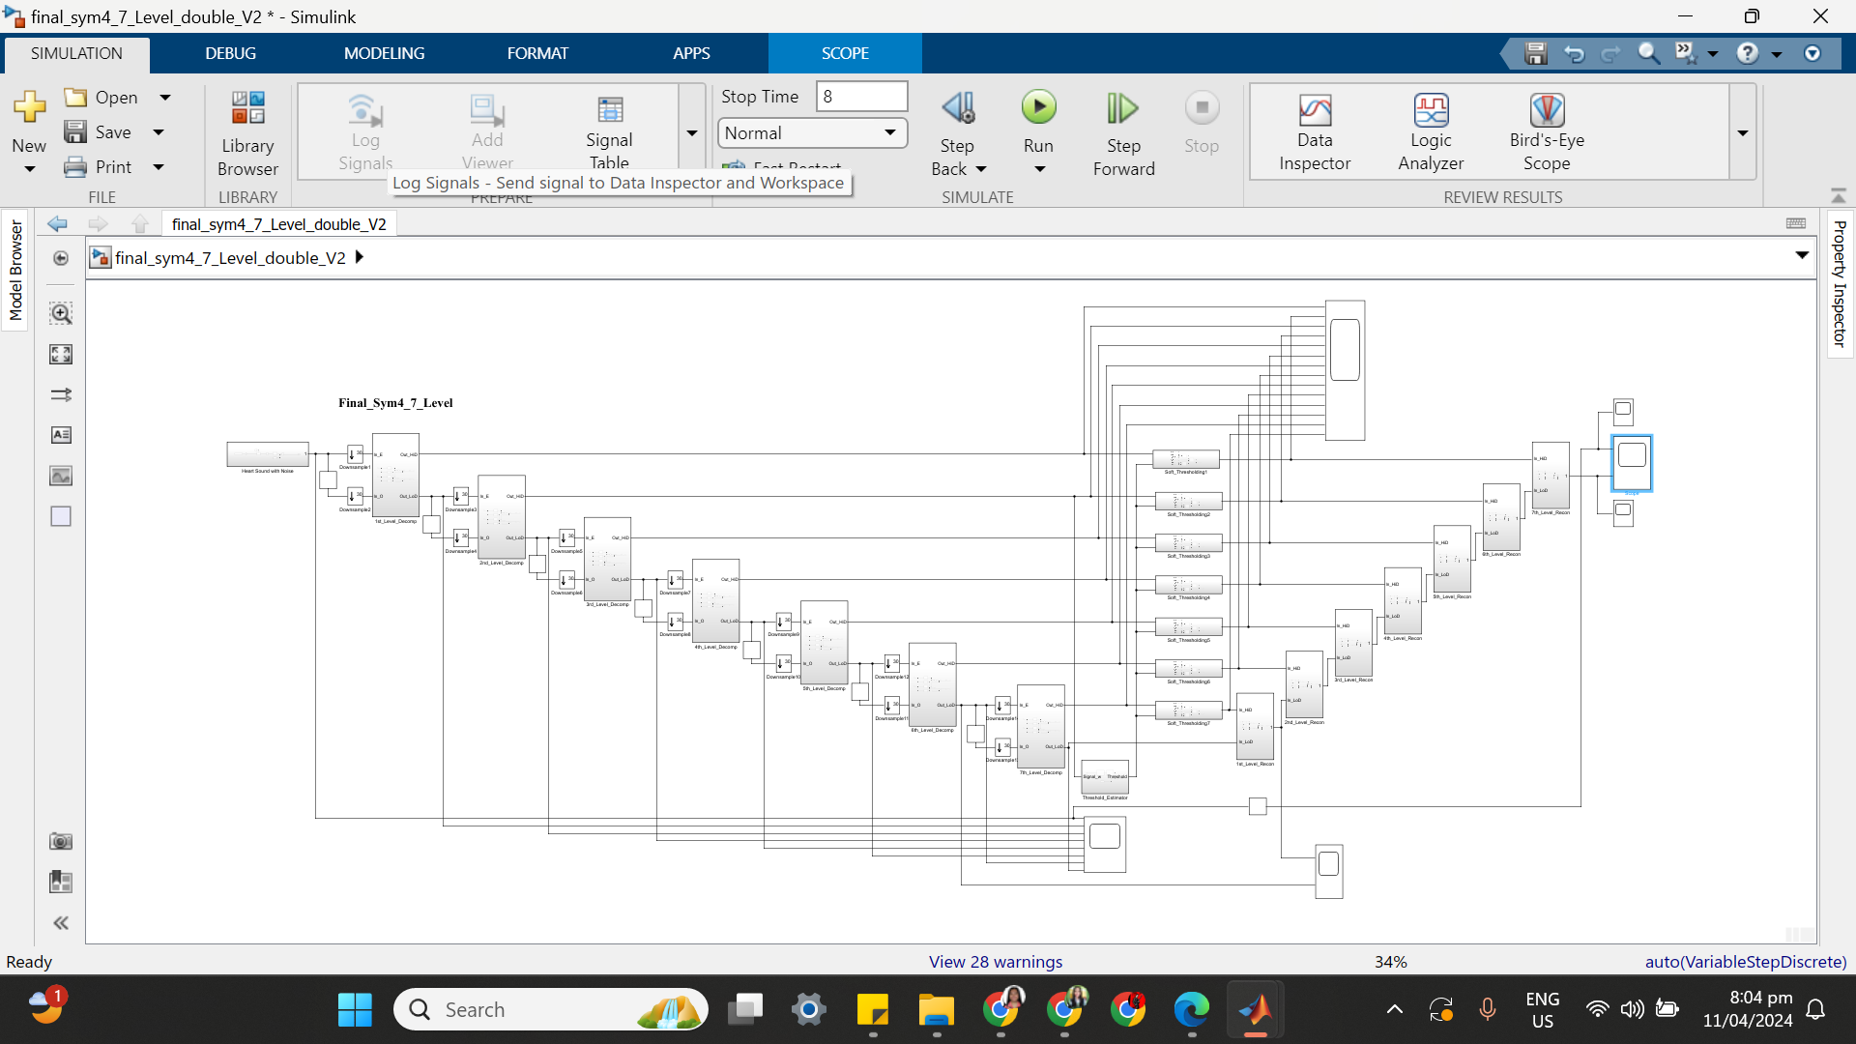

(b) SYM 4 LEVEL 7 SIMULATION RESULT

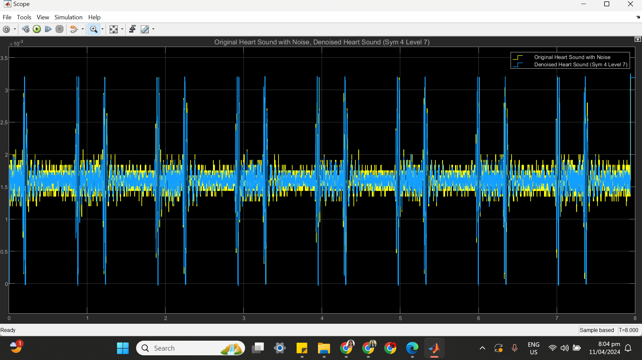

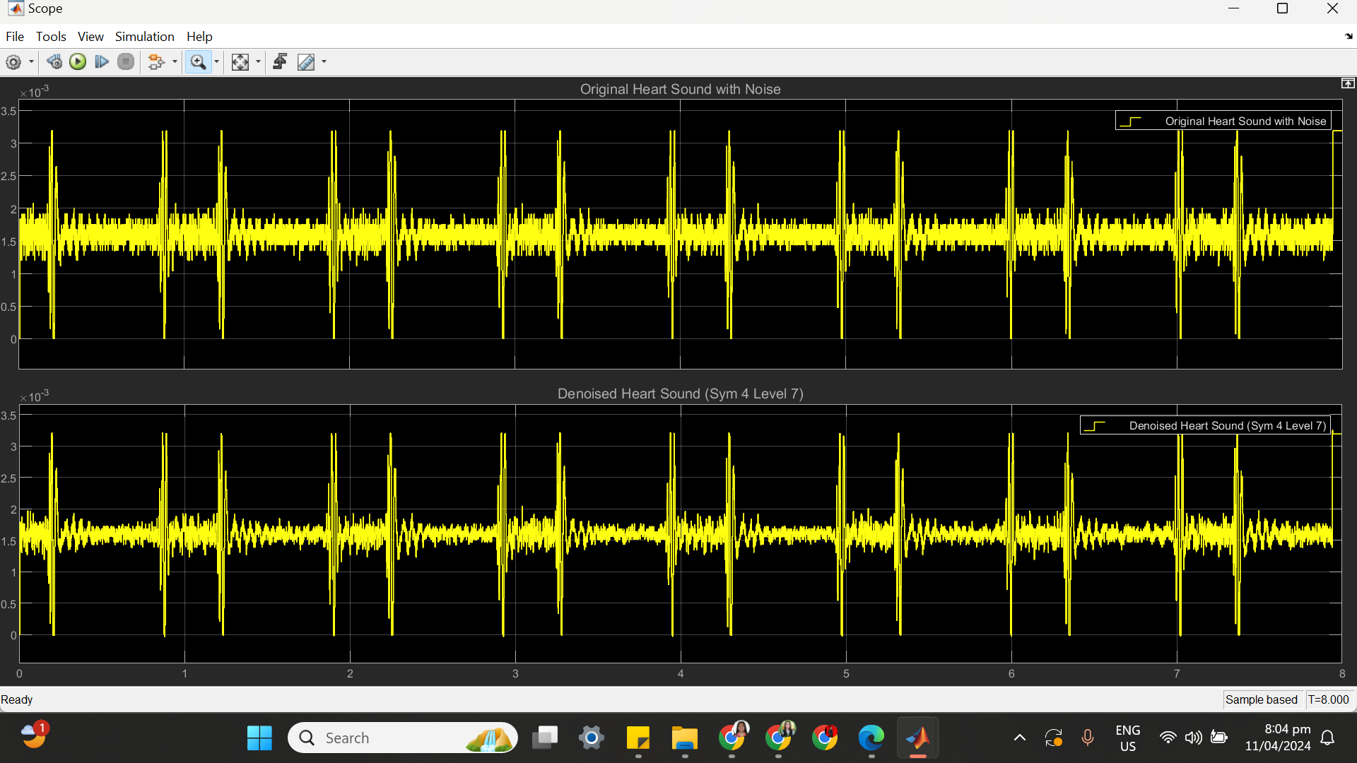

(c) SYM 4 LEVEL 7 STATISTICS RESULT

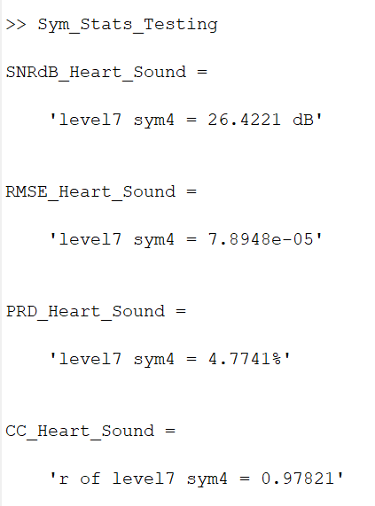

(d) SYM 4 LEVEL 7 SCATTER PLOT RESULT

